**Kafka Ecosystem – The Big Picture**

* **Items we are going to cover:**

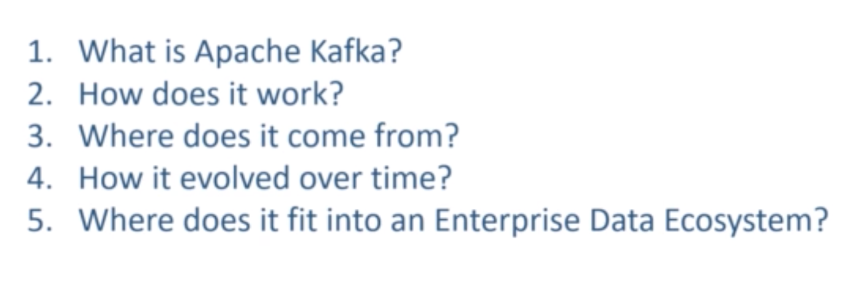

* **What is Apache Kafka?**

Creating real-time data streams.

Processing real-time data streams.

Real time means, minutes, seconds and milli second.

Below part is called creating real-time data streams:

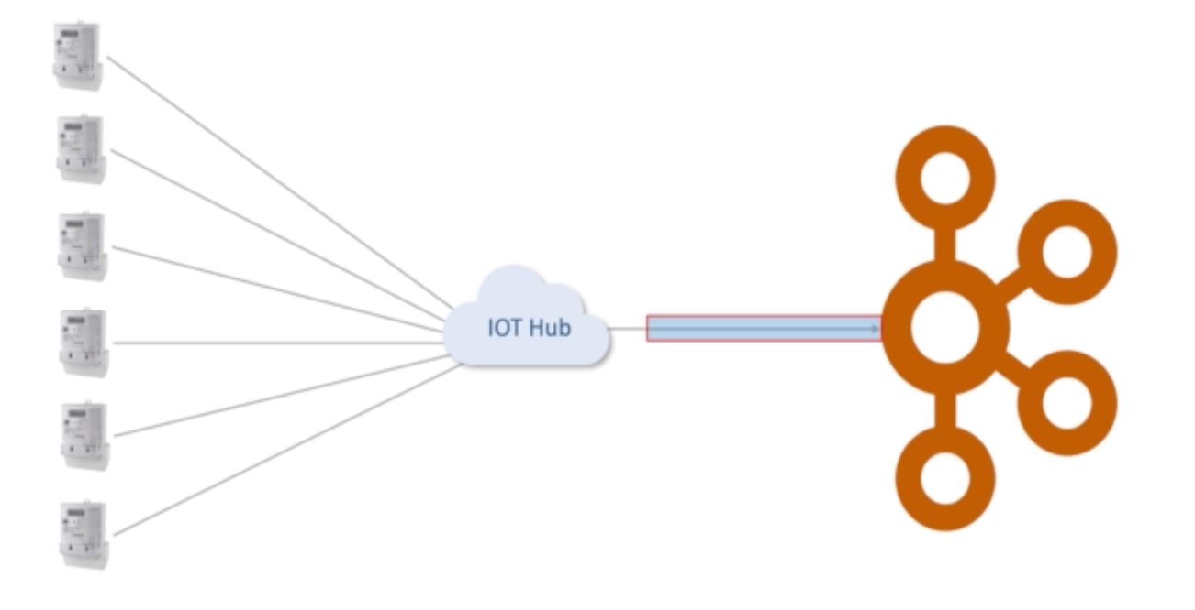

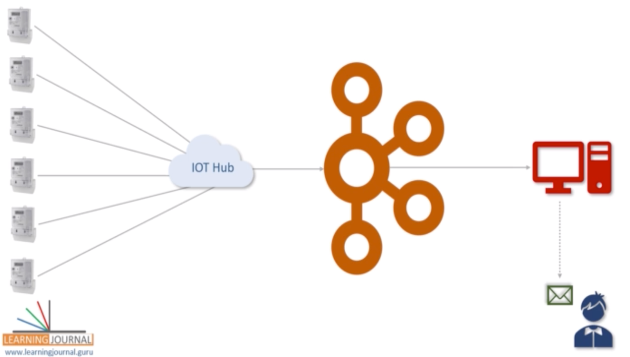

Let’say we are reading the power related data from all houses and sending it to Kafka server, Kakfa checks each reading, for any reading if it reaches a threshold value, it has to send an SMS to the owner. This has to happen immediately, as and when it reaches the threshold, not after accumulating data. So this is what we mean real-time data streaming.

What is Kafka?

Apache Kafka is a highly scalable, and distributed platform for creating and processing streams in real-time.

* **How does it work?**

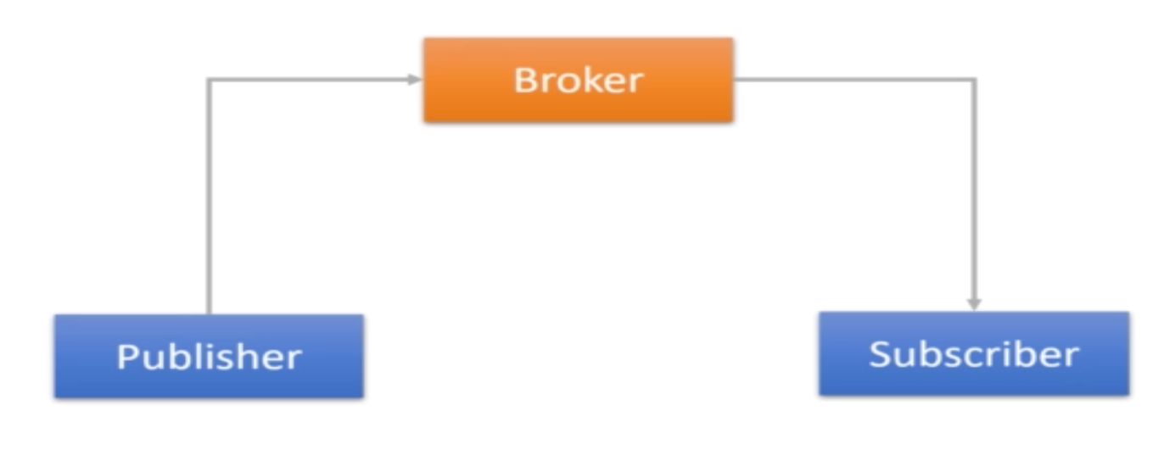

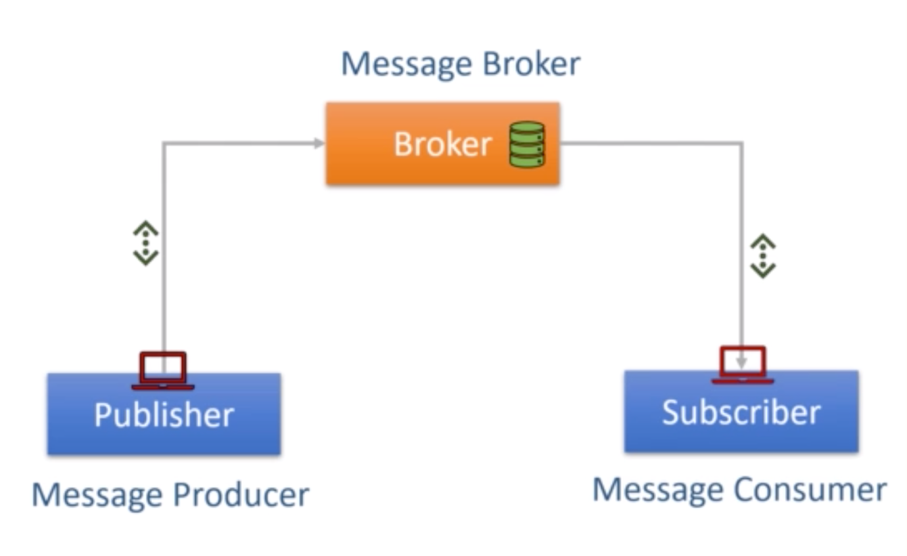

* **Who created Kafka & Why?**

Created at LinkedIn and open sourced in 2011. Initially Kafka was created to address the data integration problem.

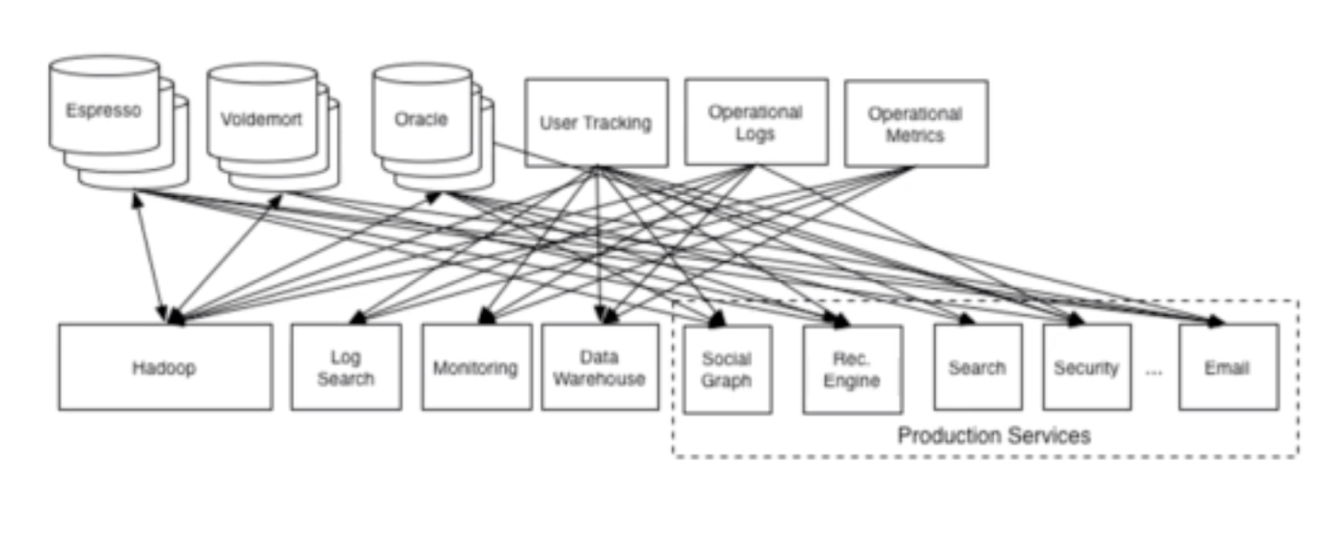

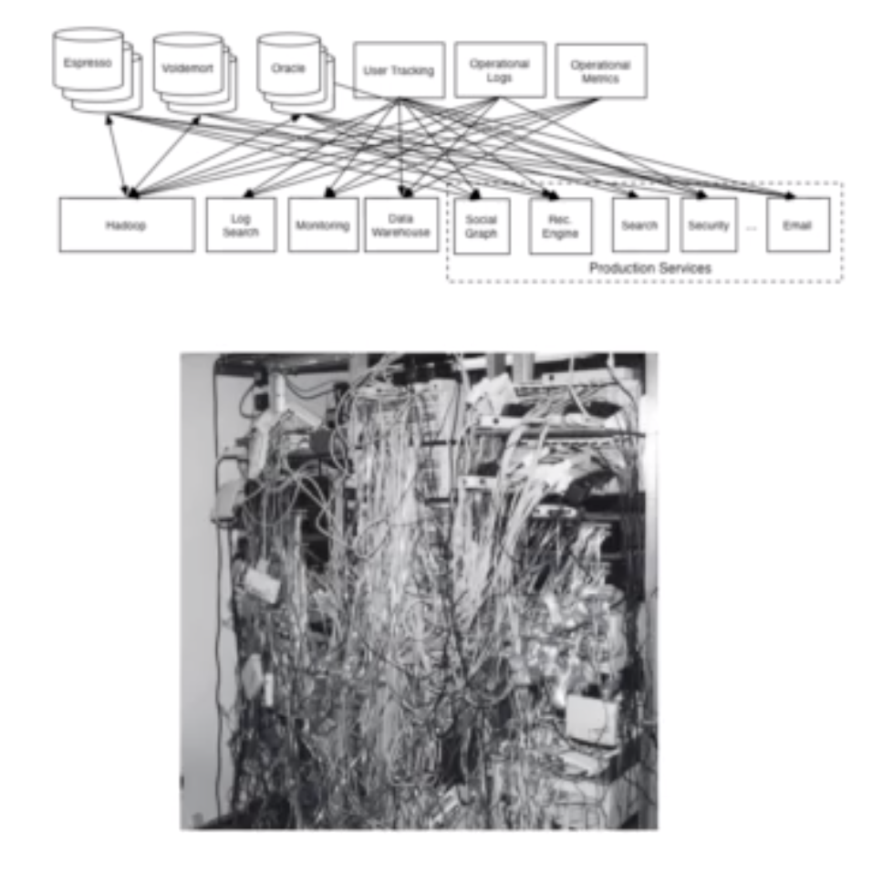

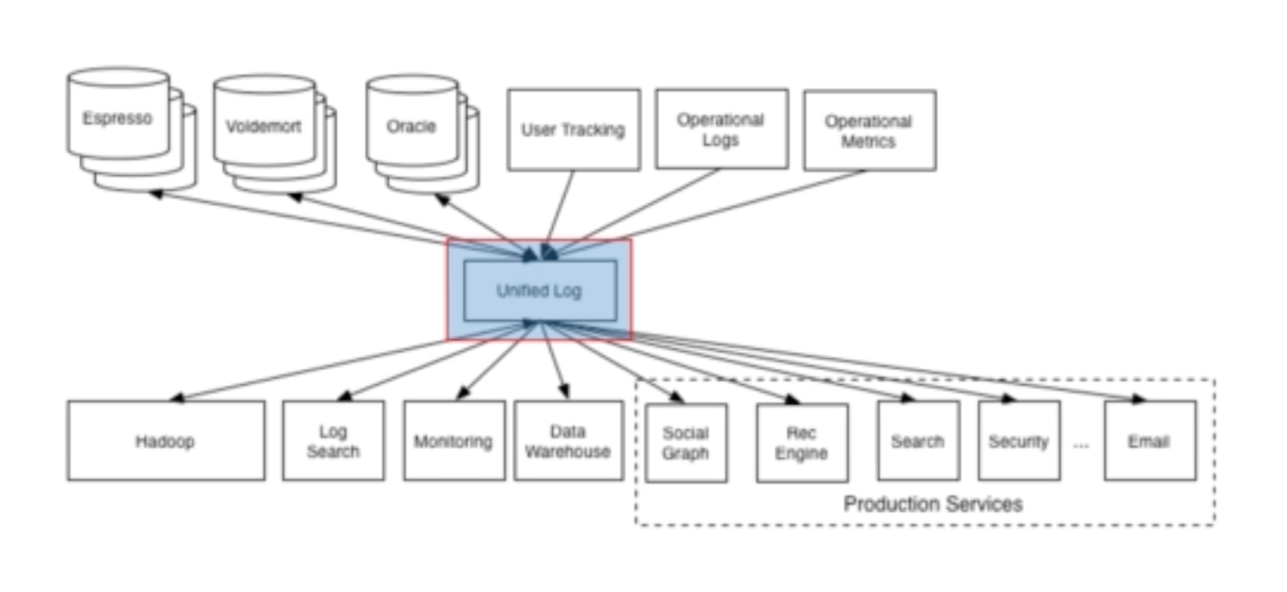

* **How Kafka evolved?**

Initially Kafka had the following two components:

1. Server Software – Broker.
2. Client API – Java library
   1. Producer API
   2. Consumer API

Later on it got sub-divided into following components:

1. Kafka connect – Open source
2. Kafka streams – Open source
3. KSQL – Commercial maintained by Confluent.

The following are the final list of components 2011 to 2019:

1. Kafka broker – Central server system.
2. Kafka client – Kafka APIs (producer and consumer).
3. Kafka connect – Used for initial integration problem.
4. Kafka streams – Creating and processing real-time streams.
5. KSQL – Kafka is trying to become a database.

* **Where does it fit in to enterprise ecosystem:**

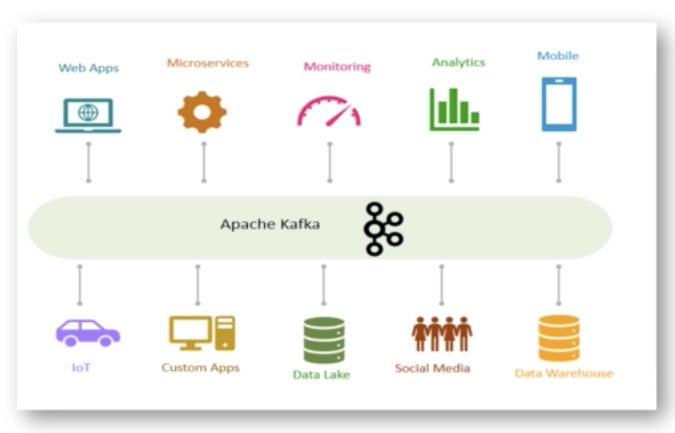

* **Apache Kafka Core Concepts:**

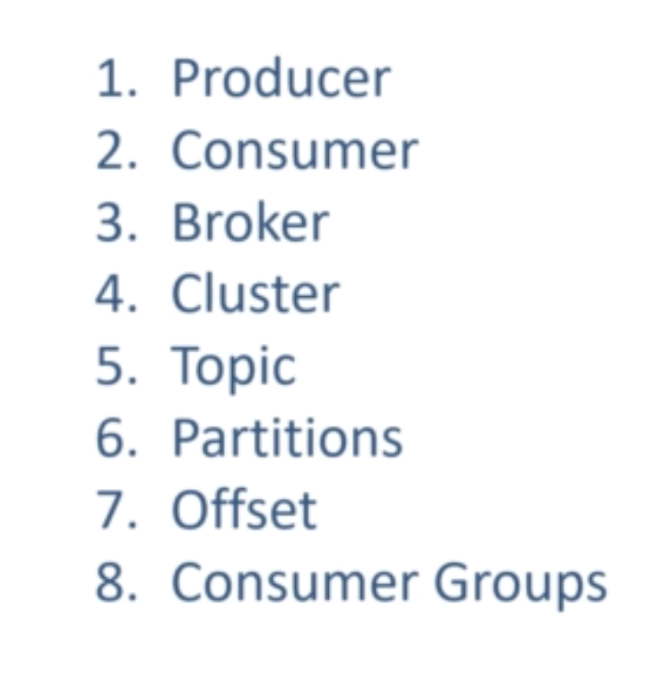

1. **Producer:**

A producer is an application which produces and sends a message to Kafka.

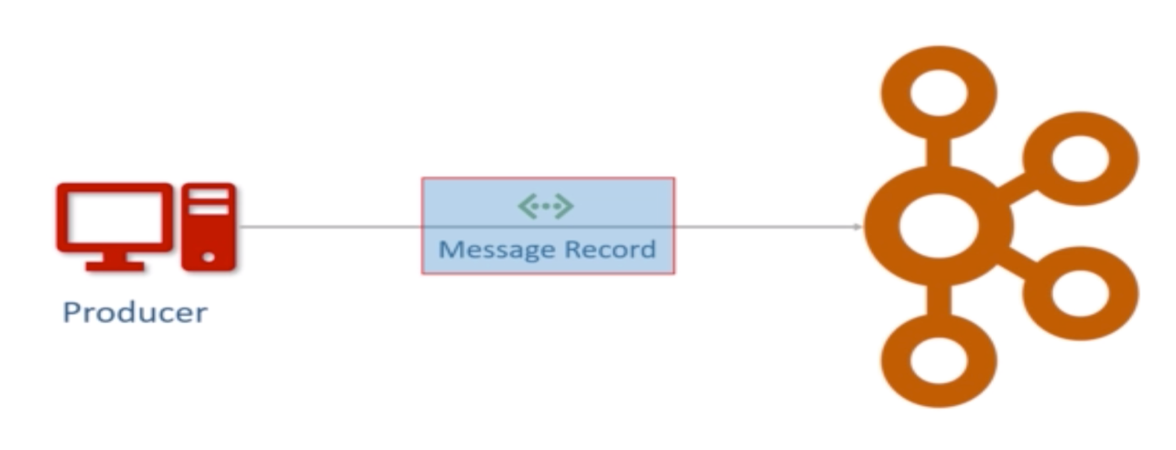

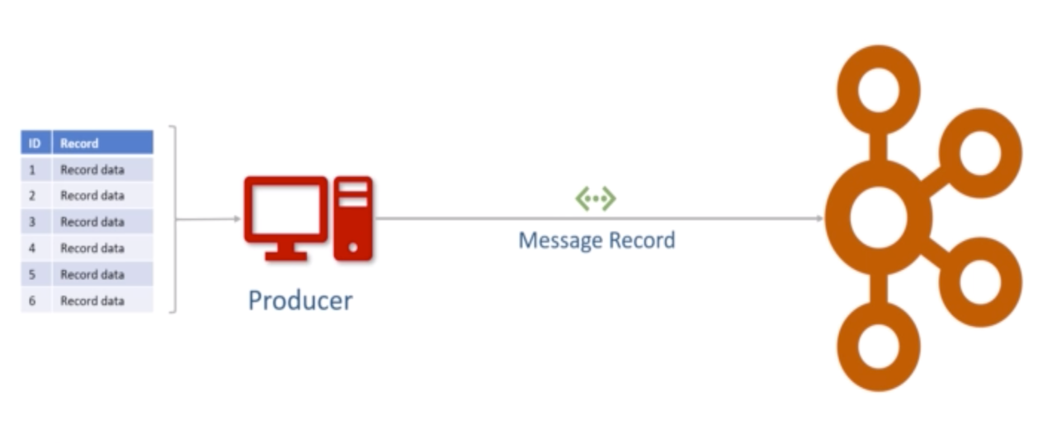

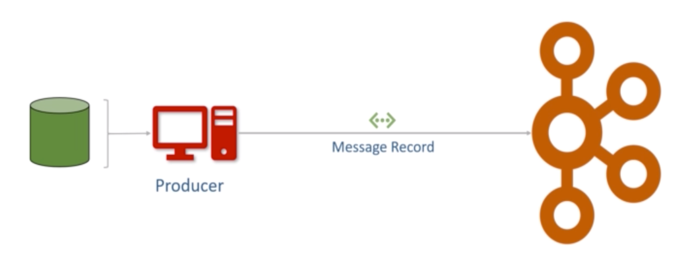

1. **What is a consumer?**

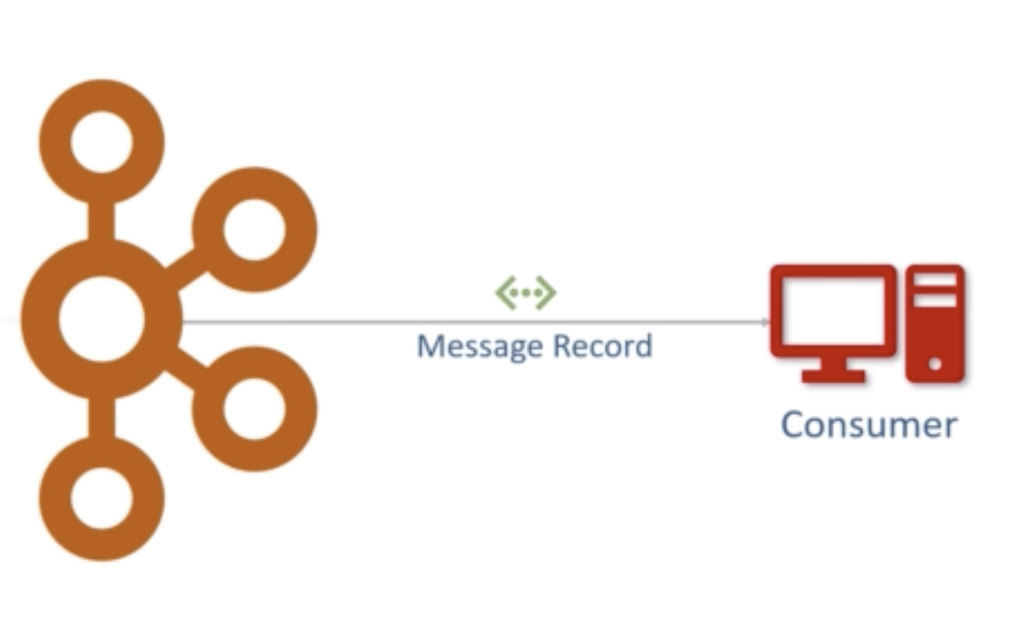

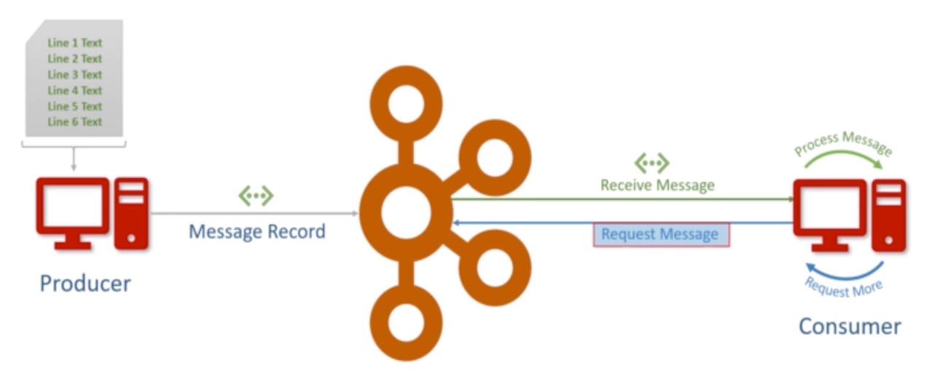

1. **What is a Broker?**

Broker is the name given to the Kafka server.

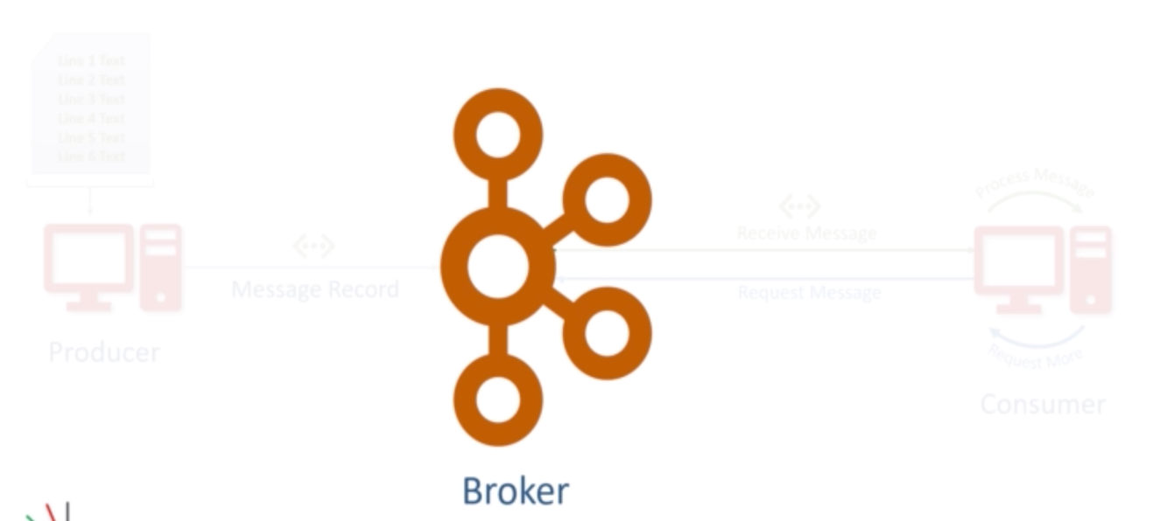

1. **What is a cluster?**

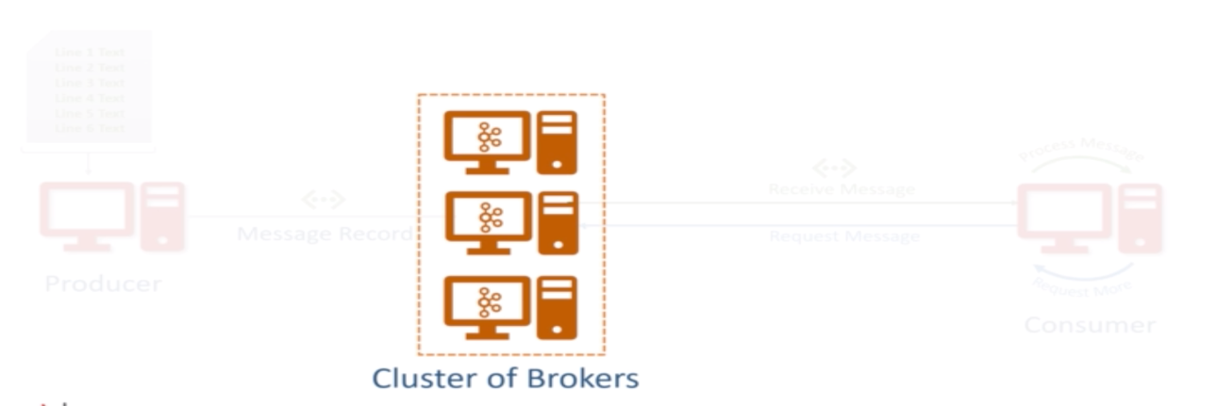

1. **What is a Kafka Topic?**

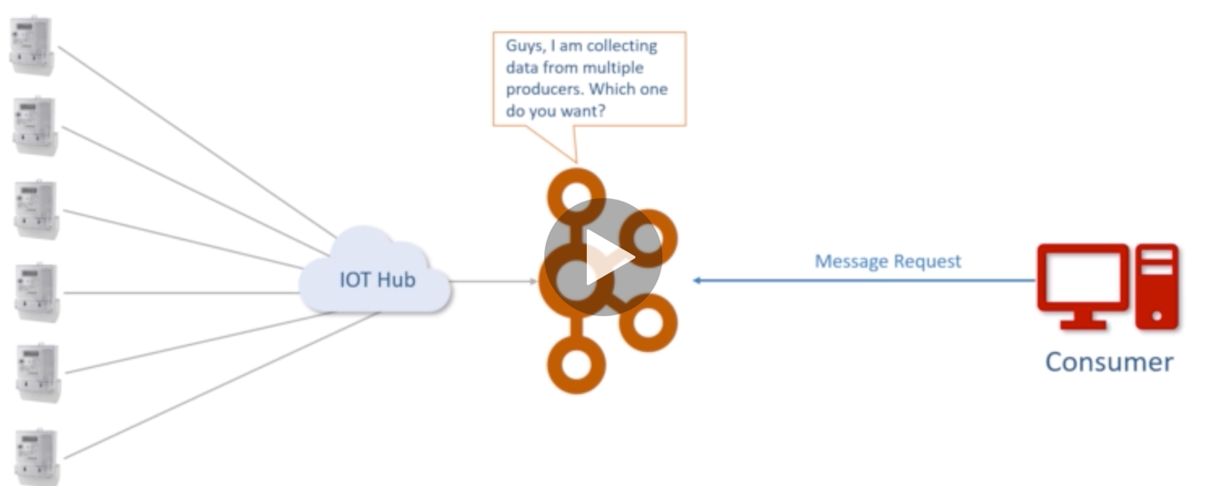

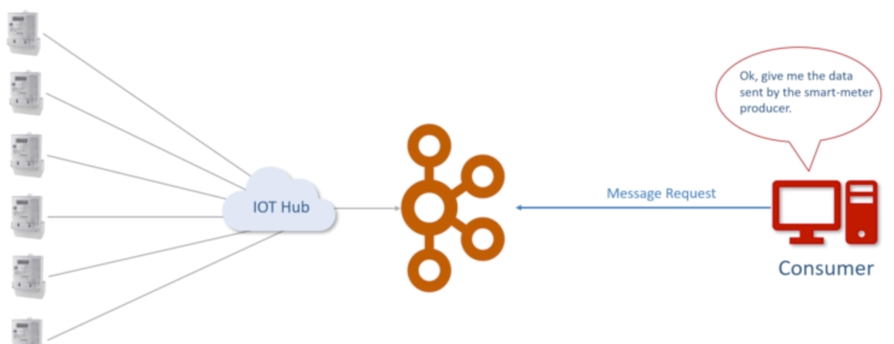

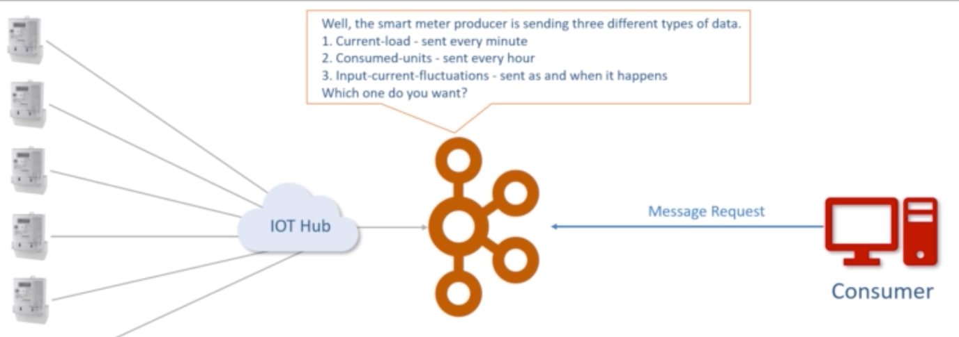

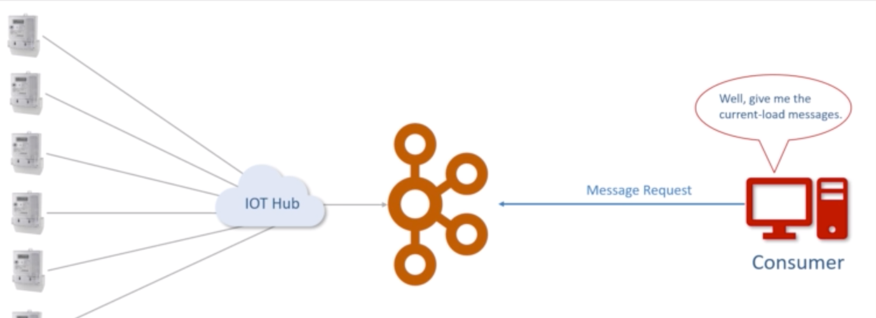

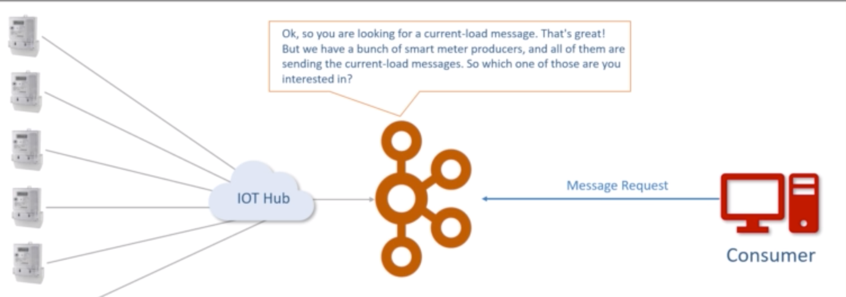

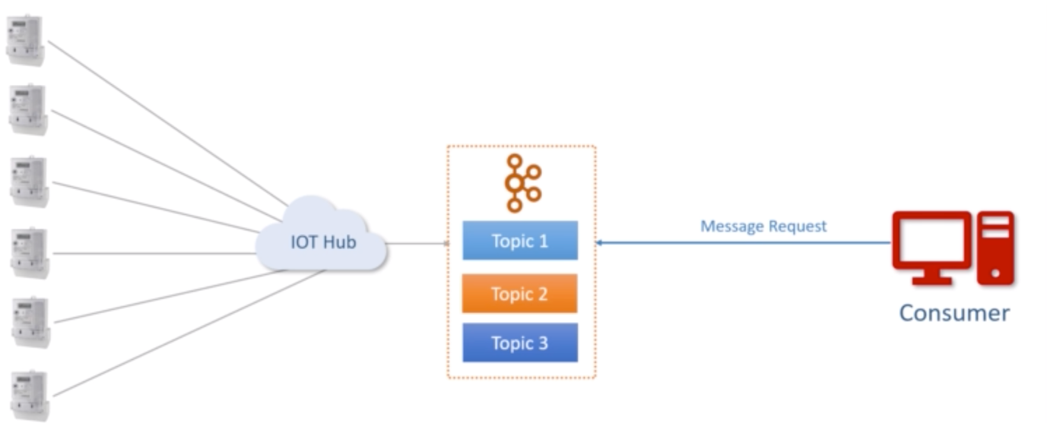

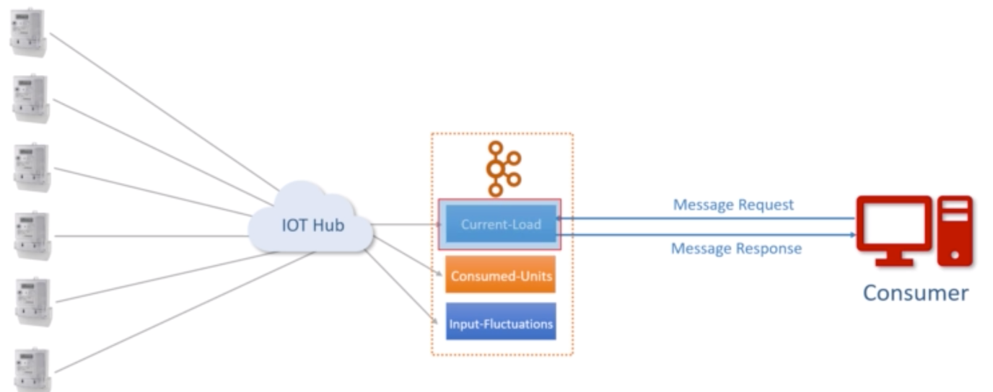

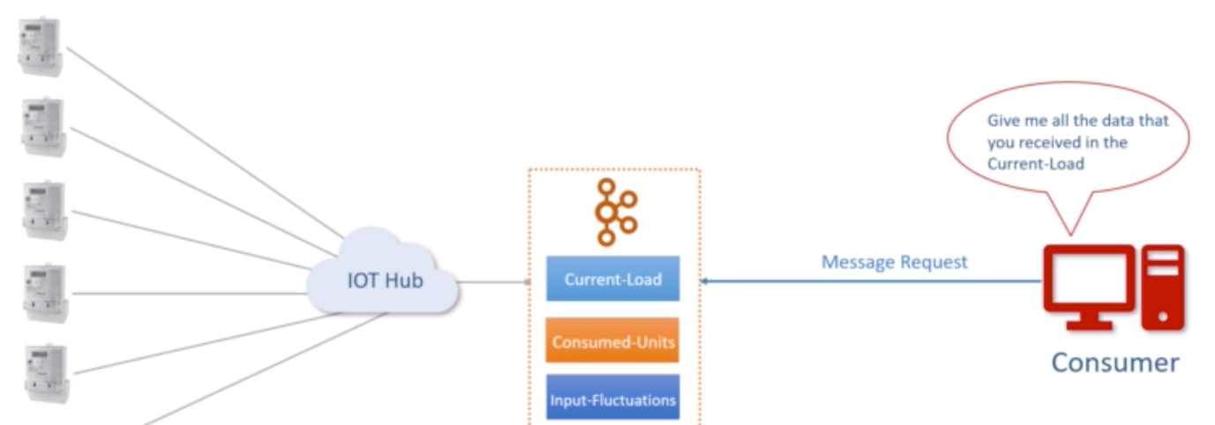

1. **What are topic Partitions?**

A small and independent portion of the topic, is topic partition.

Number of topic partitions may vary based on the scenario or business need?

Deciding number of topic partition is a design decision.

Single partition will be on a single machine, partition can’t be shared across machines.

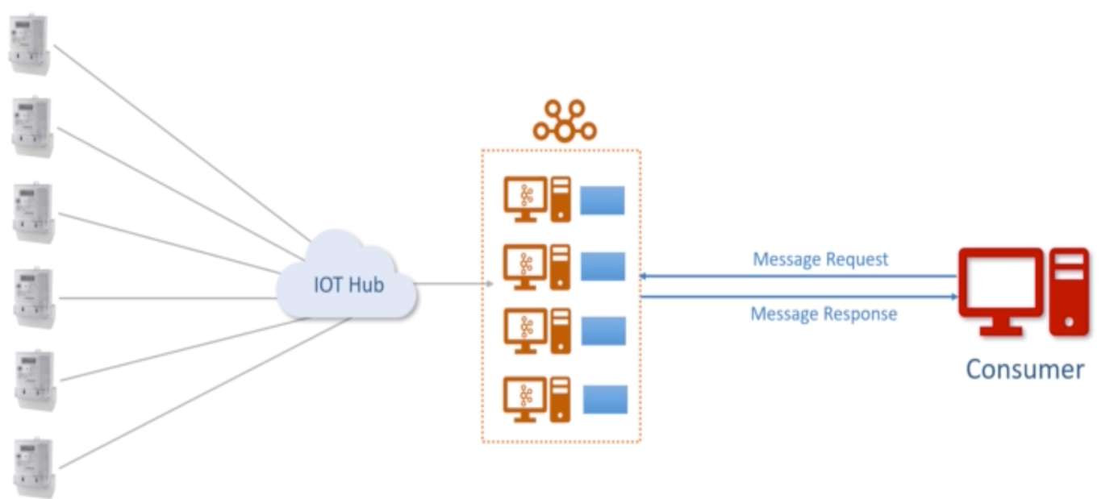

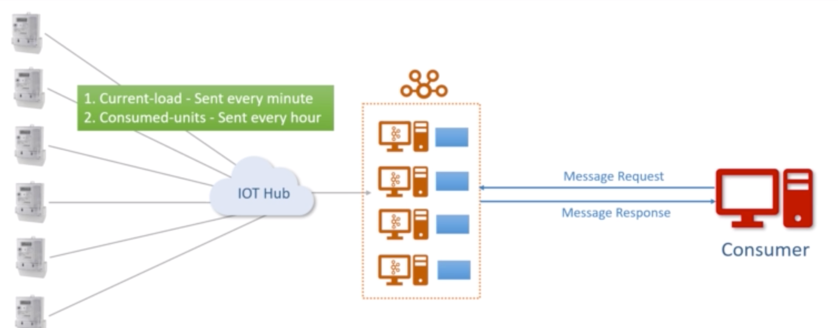

1. **What is partition off-set?**

Off-set is a unique sequence id of message for a given partition.

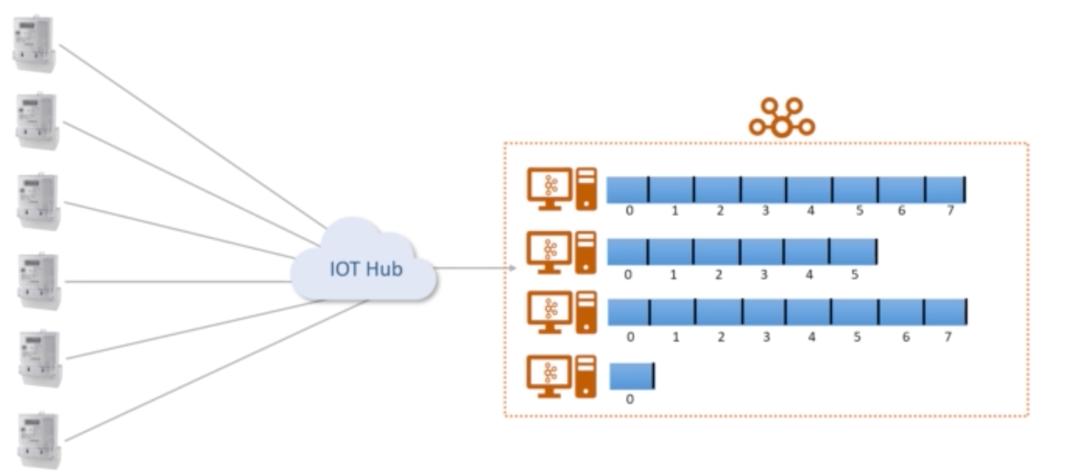

The sequence ids are generated by broker and assigned to every message as it arrives in the partition. These ids are immutable.

Note these offsets are local within the partitions. There is no global ordering in the topic across partition.

To locate a message in Kafka you need the following three details:

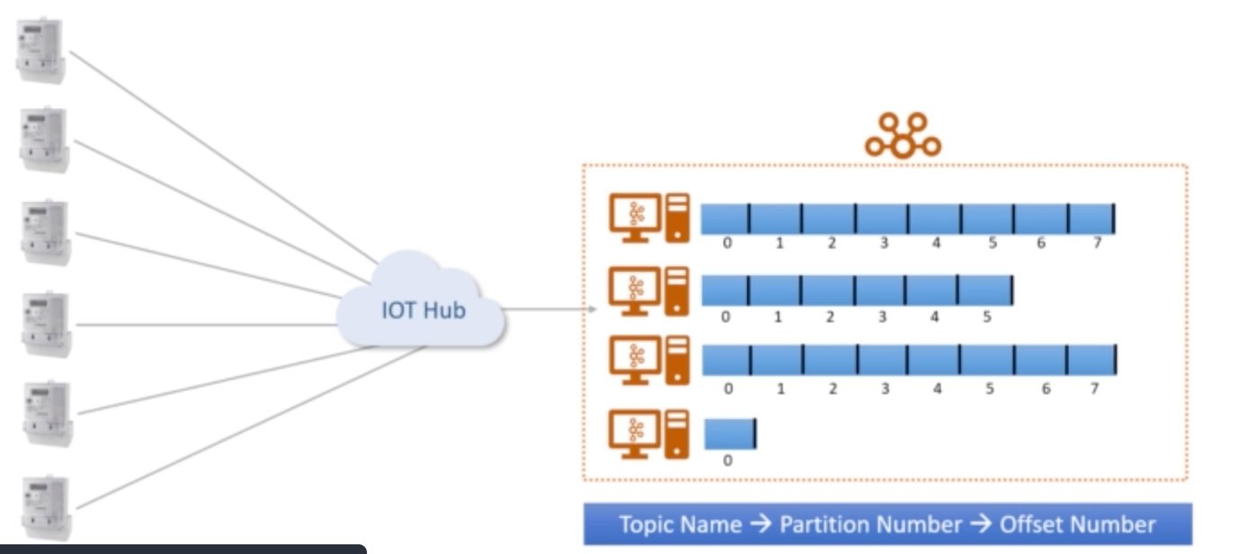

1. **What is a Consumer Group?**

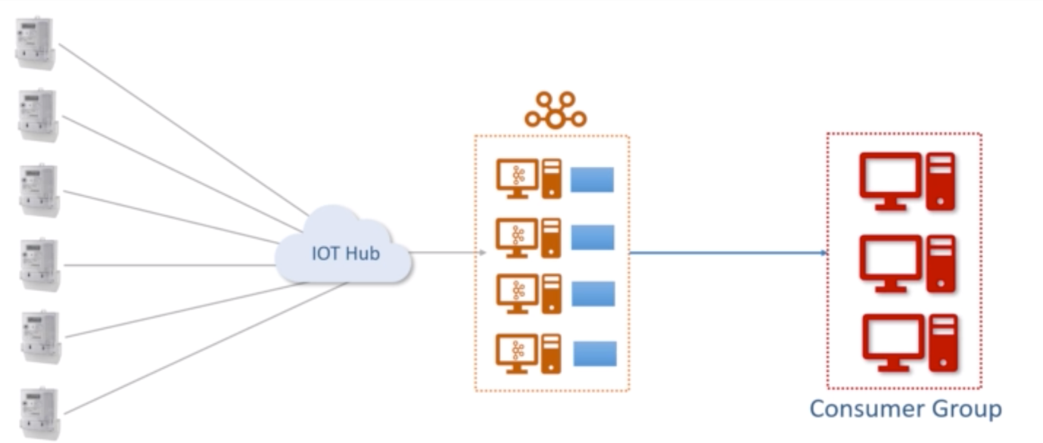

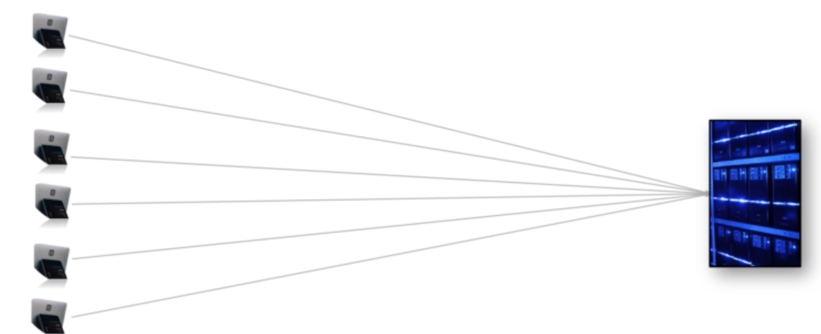

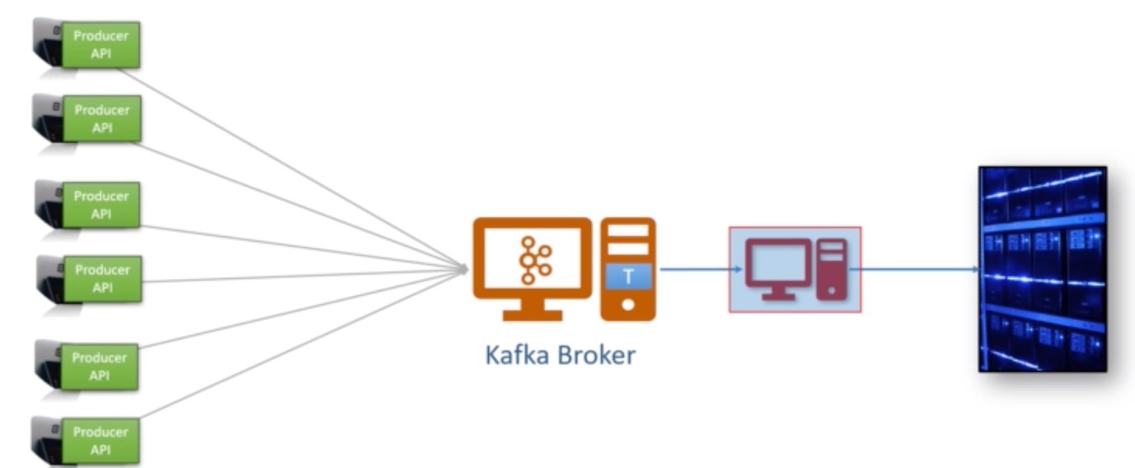

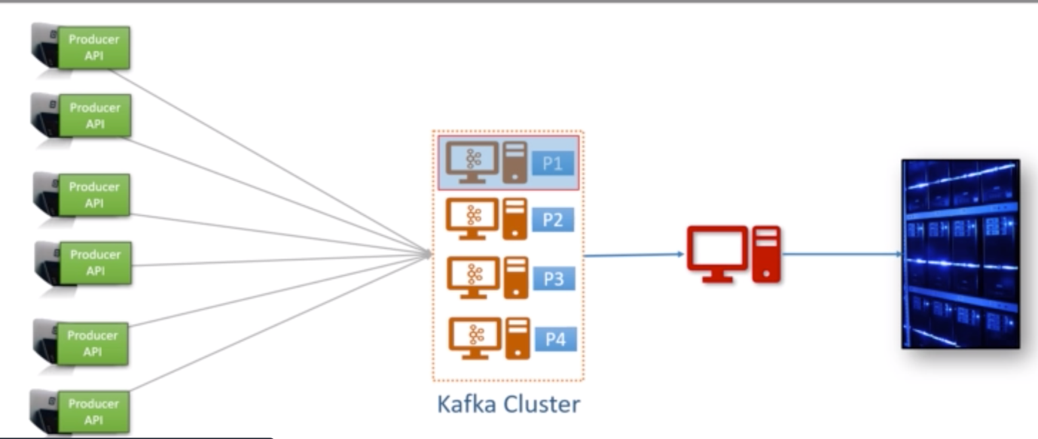

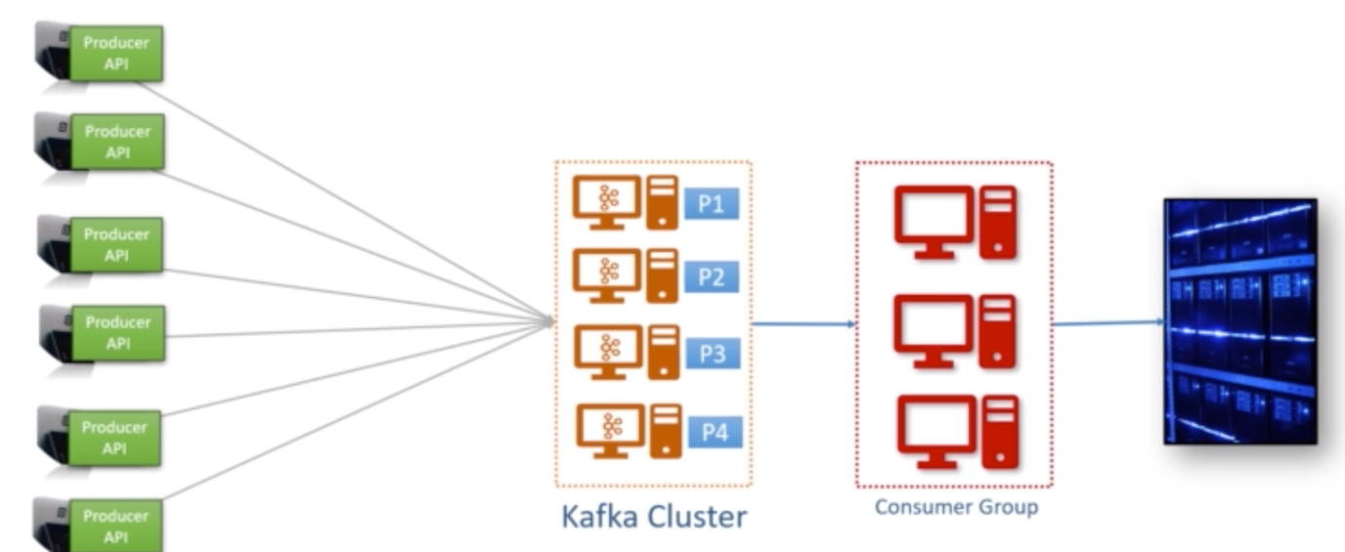

**Note:**

**In Kafka topic partition is a tool for scalability.**

**Maximum possible parallel consumers are limited by the number of partitions in the topic.**

**Kafka doesn’t allow more than one consumer to read and process data from the same partition simultaneously.**

* **Kafka Connect Core Concepts:**

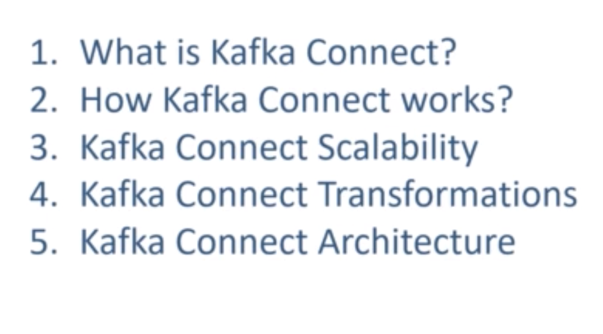

1. **What is Kafka Connect?**

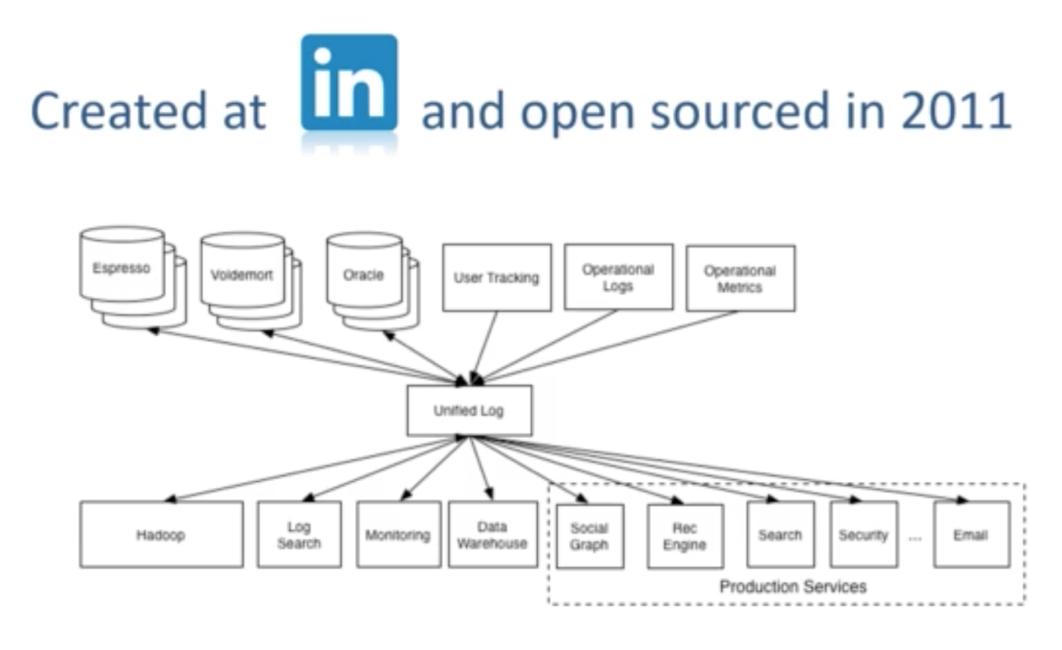

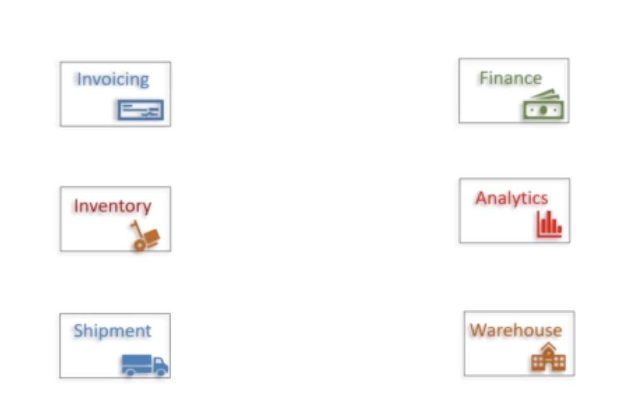

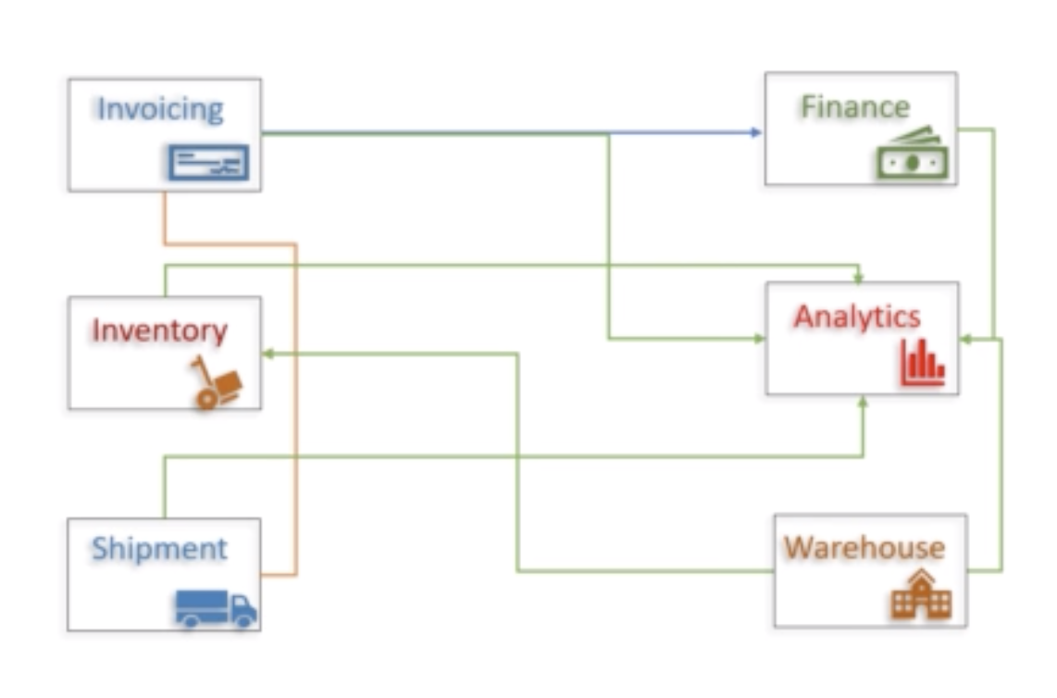

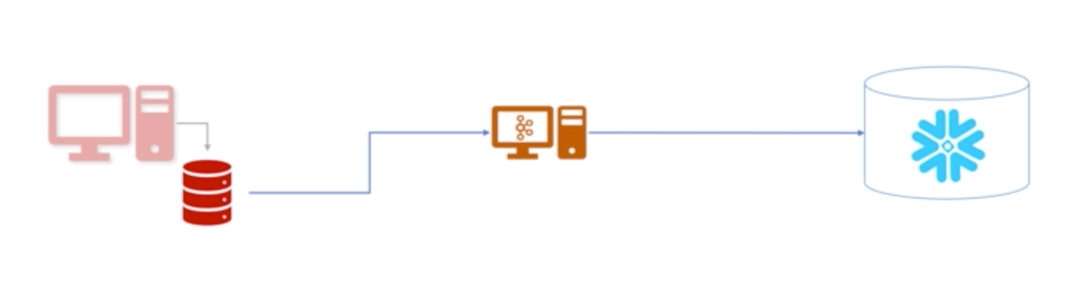

With Kafka the dependency is one to one.

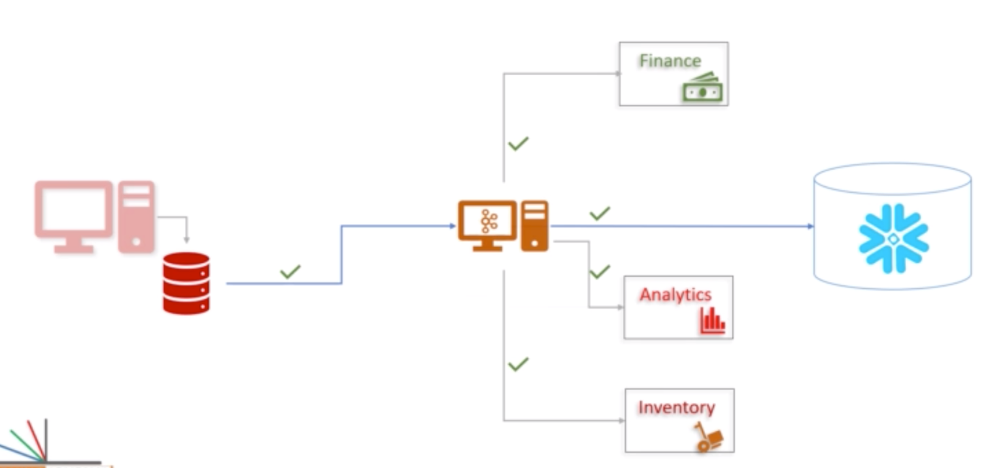

Without Kafka it is one to many

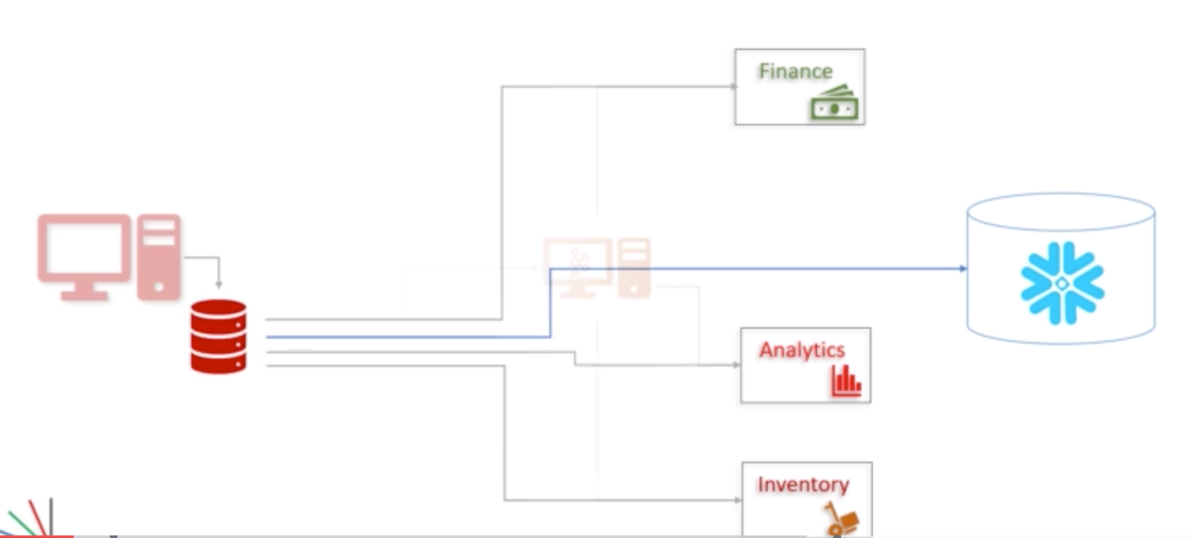

**How are we going to bring the data from source application to Kakfa?**

Option-1: Use the producer.

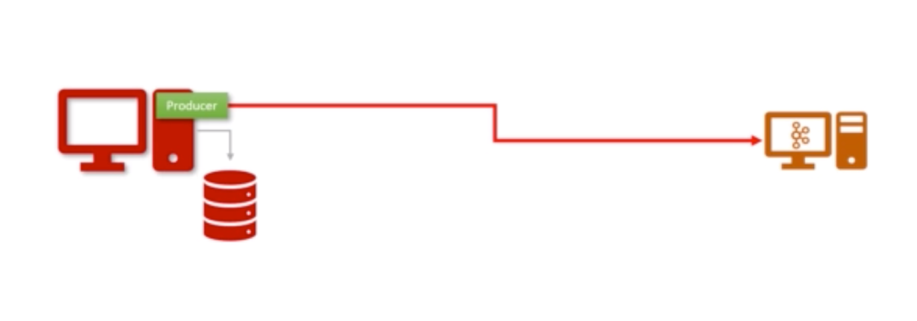

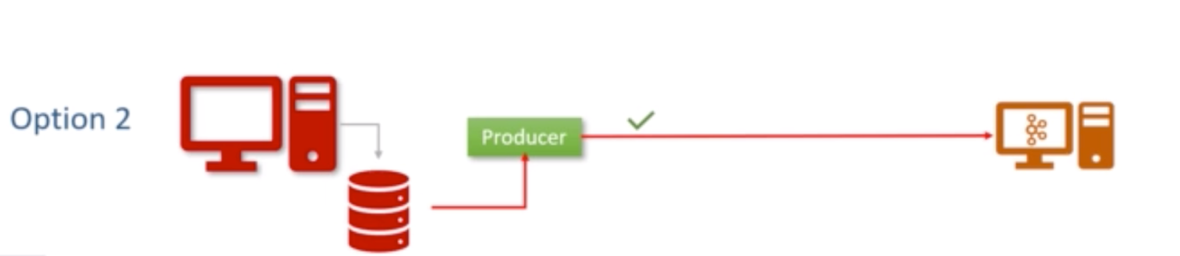

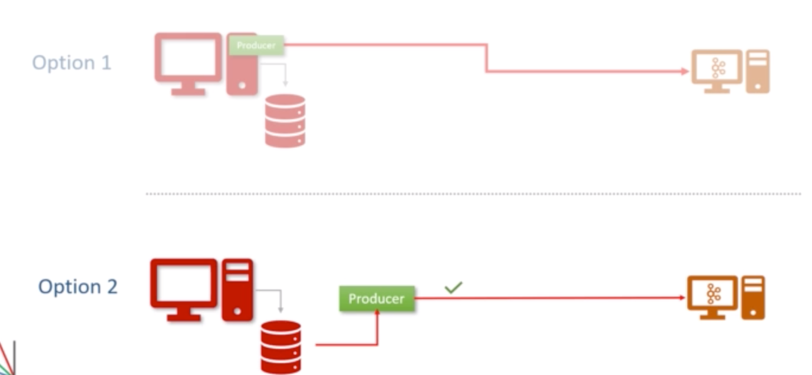

If you are going to select the second option, then this is already solved for you. That’s what Kafka connect is designed for.

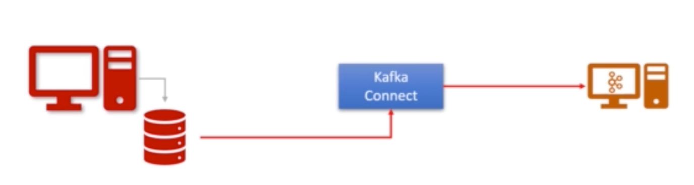

With Kafka connect no need to write a single code, it is just a configuration.

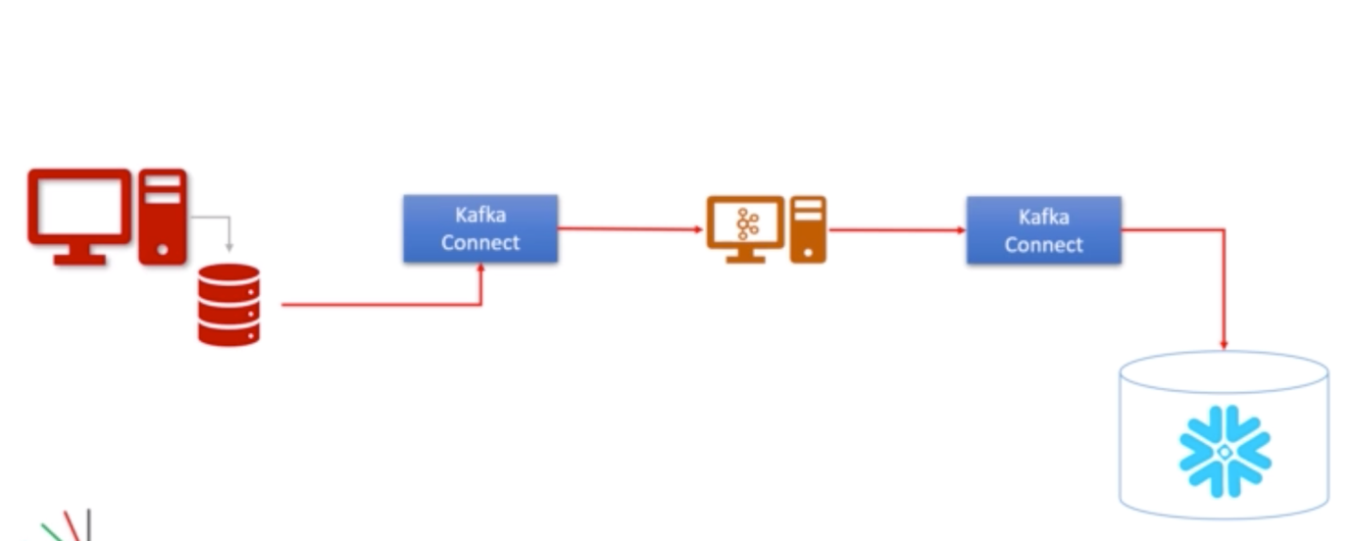

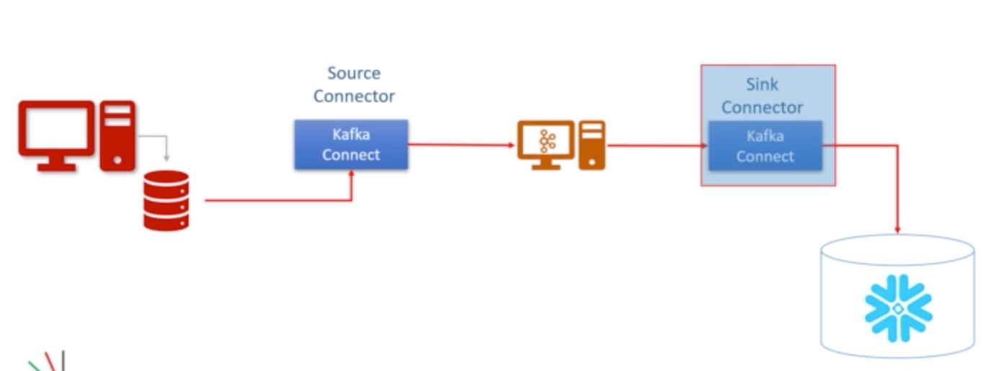

Kafka connect is a component of Kafka, for connecting and moving data between a Kafka and external systems. We have two kinds of Kafka connectors source connector and sink connectors.

1. **How Kafka Connect Works?**

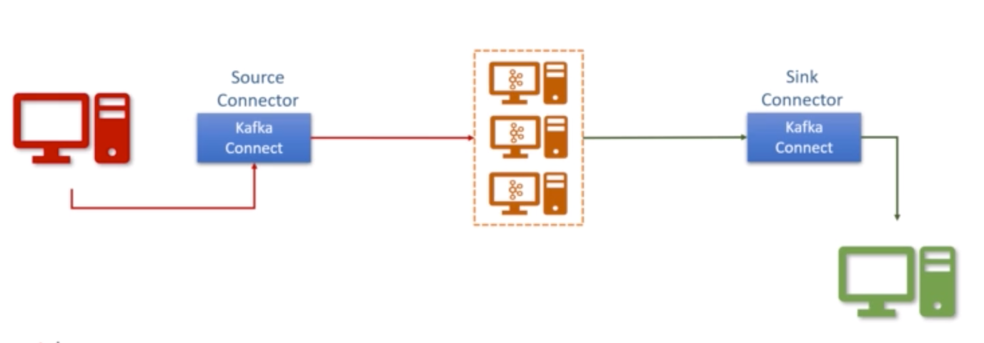

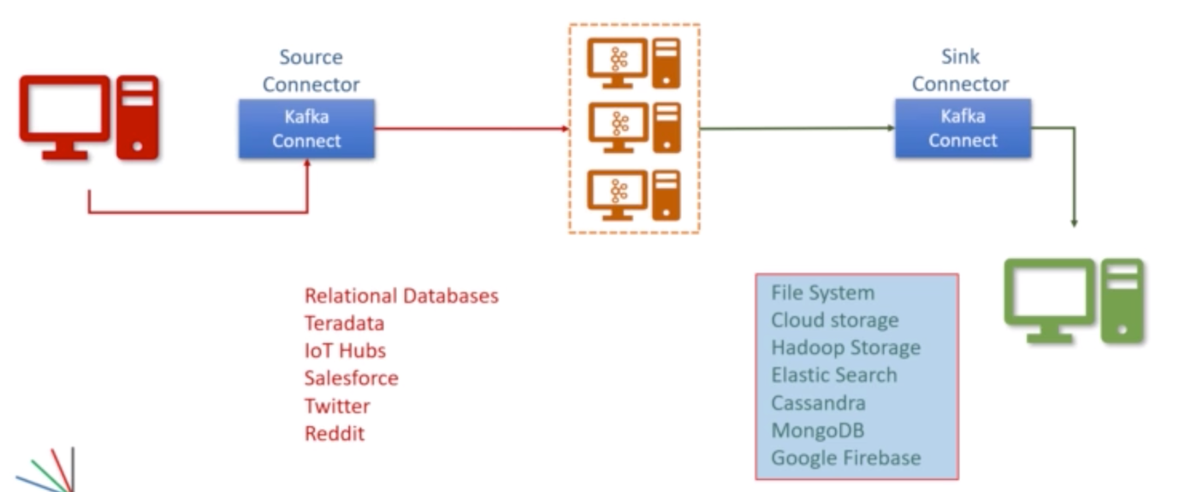

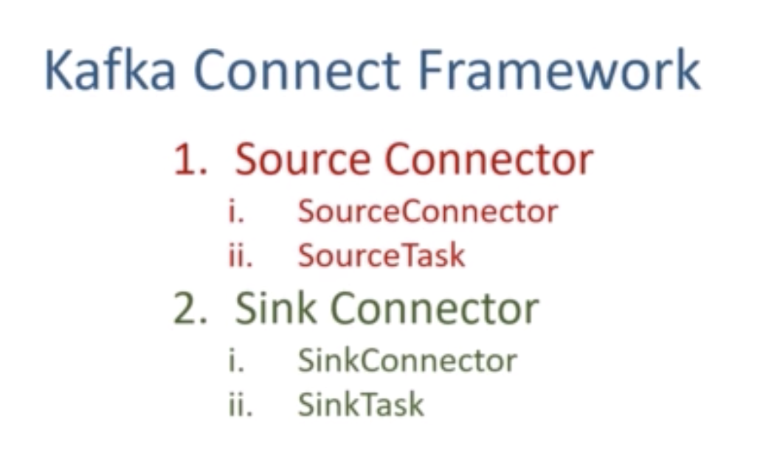

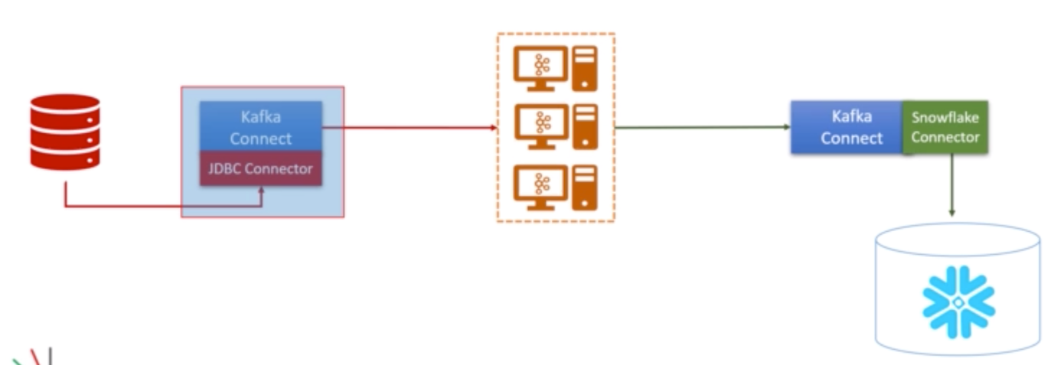

1. **Kafka Connect Scalability:**

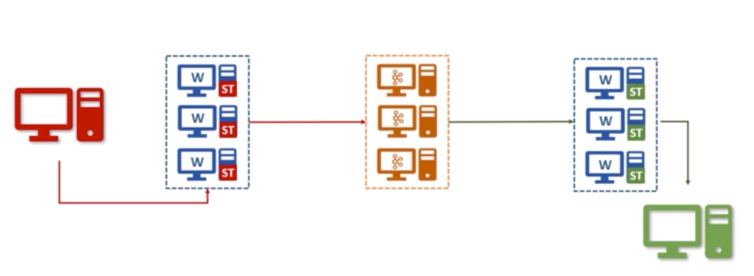

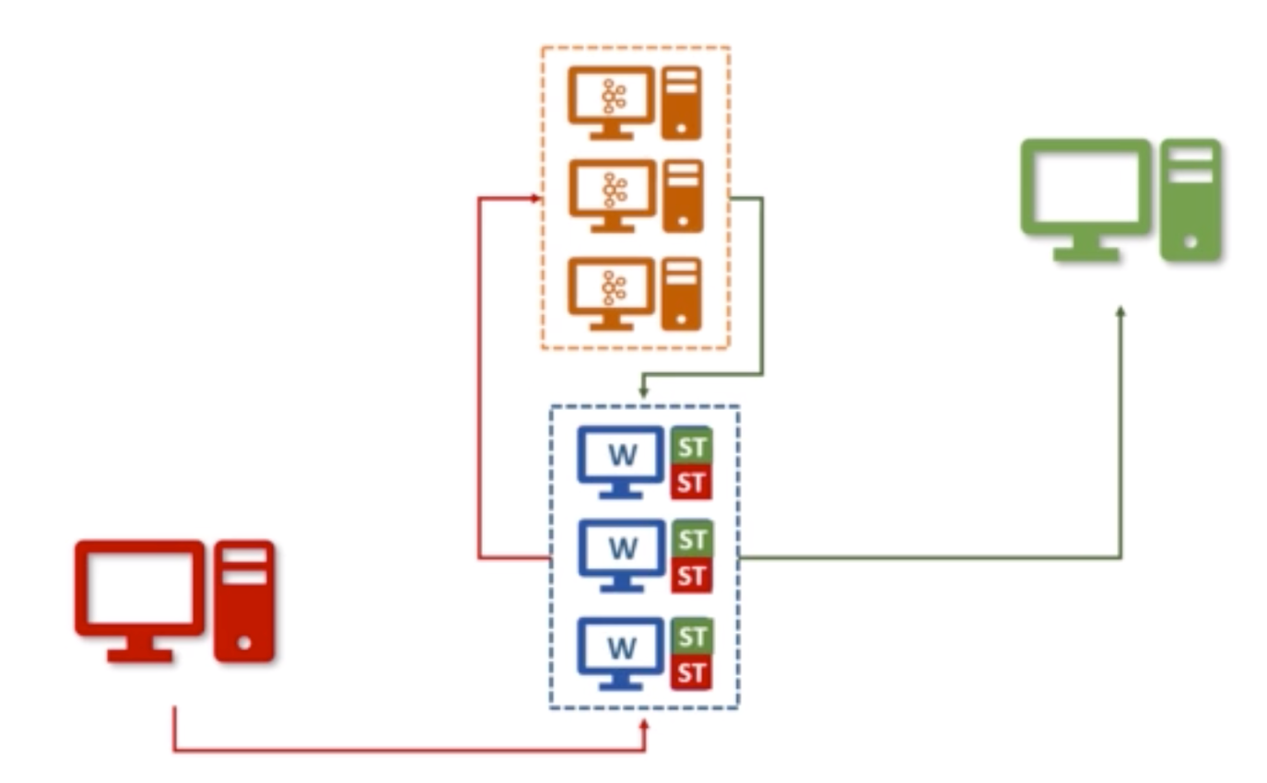

1. **Connect Transformations:**

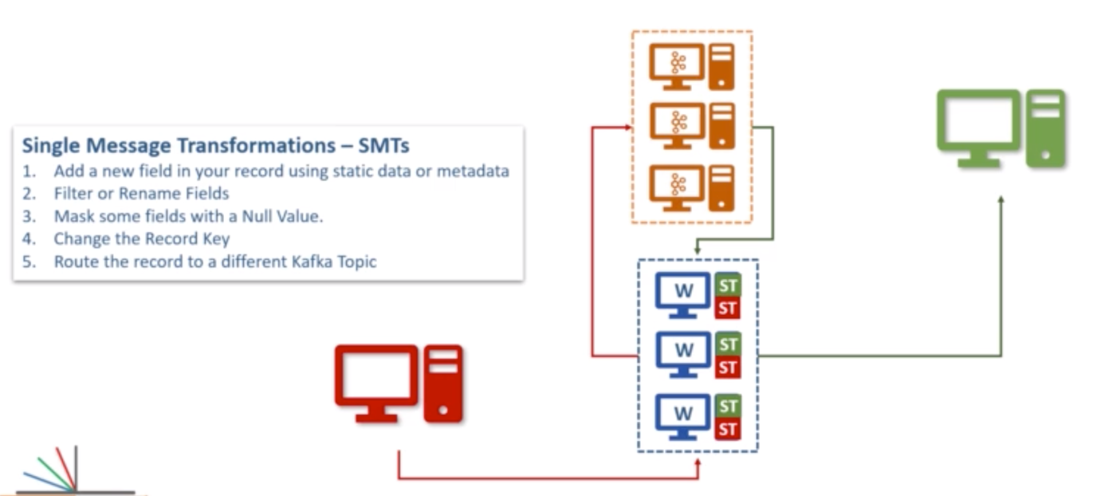

1. **Kafka Connect Architecture:**

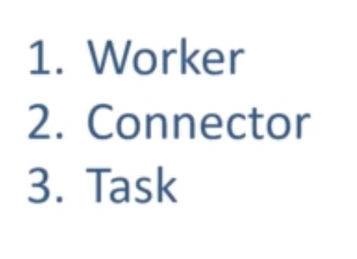

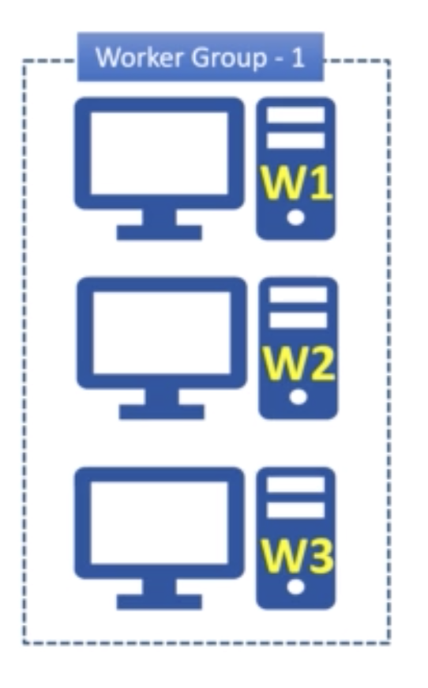

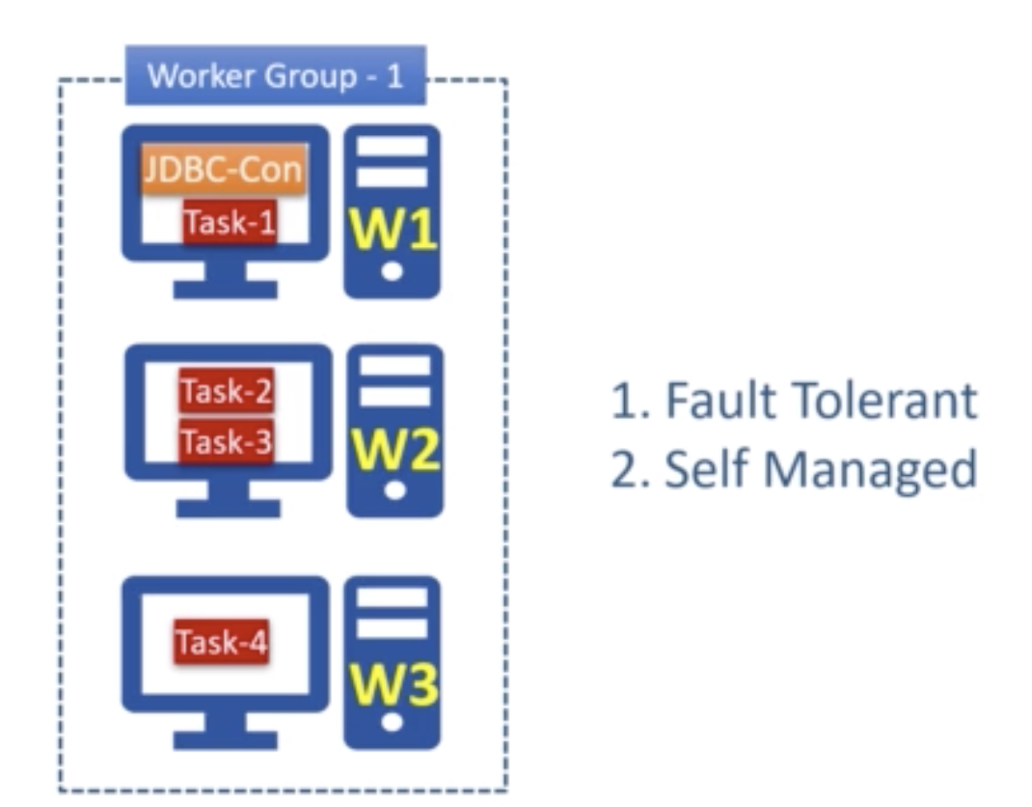

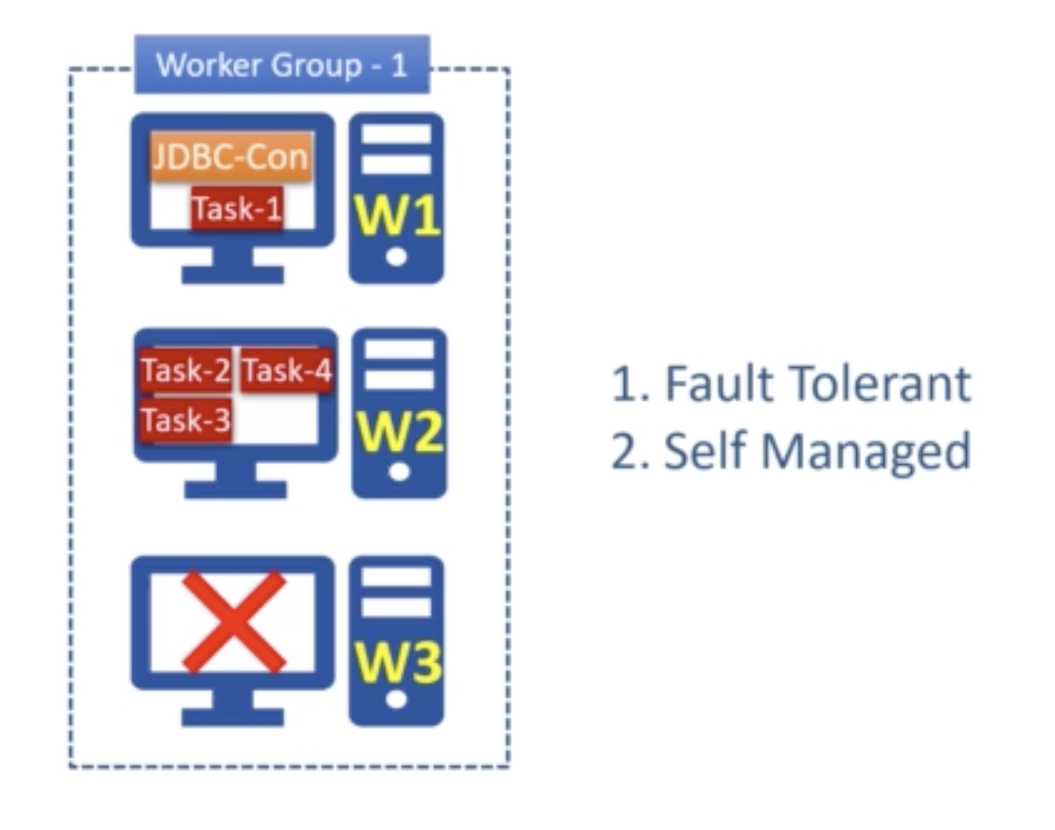

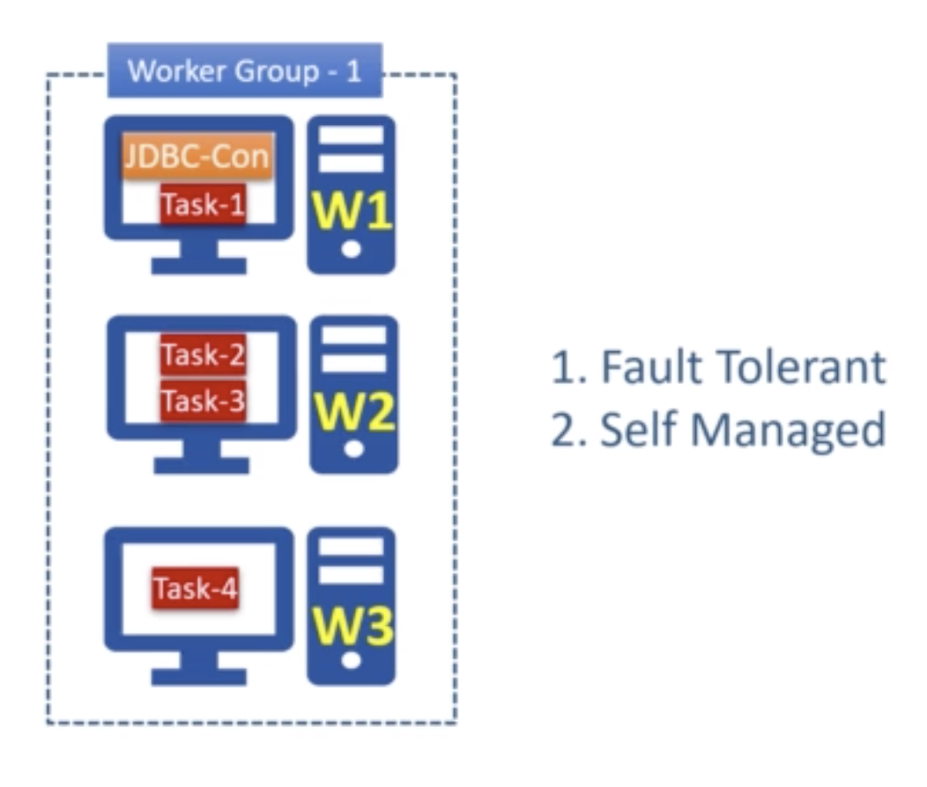

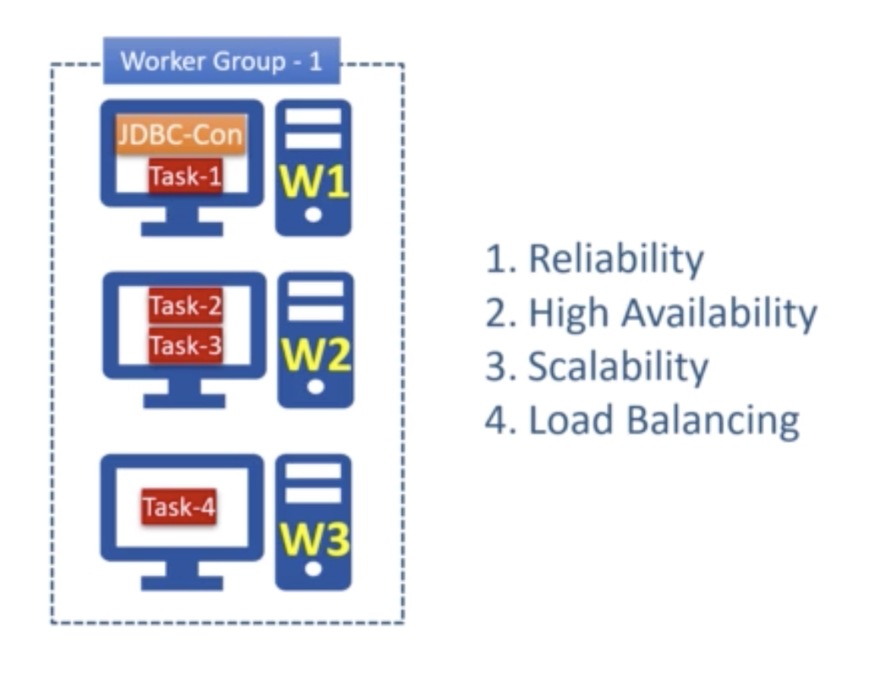



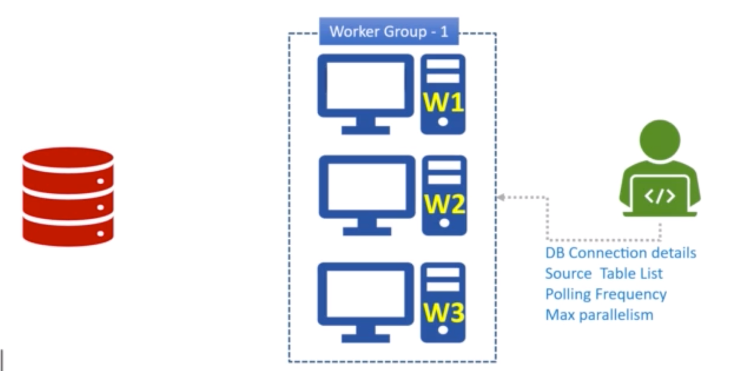

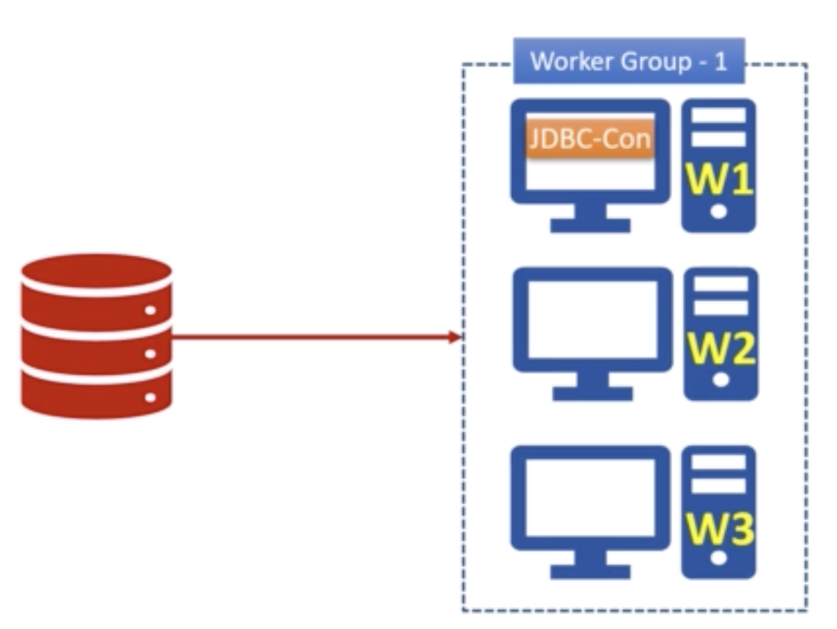

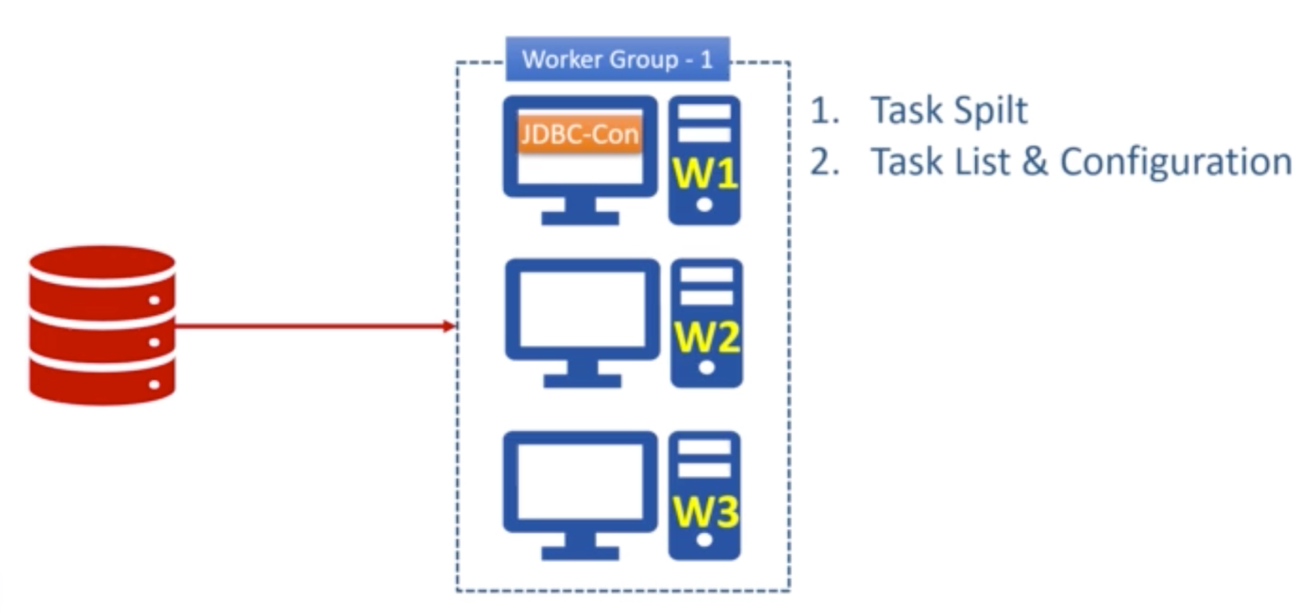

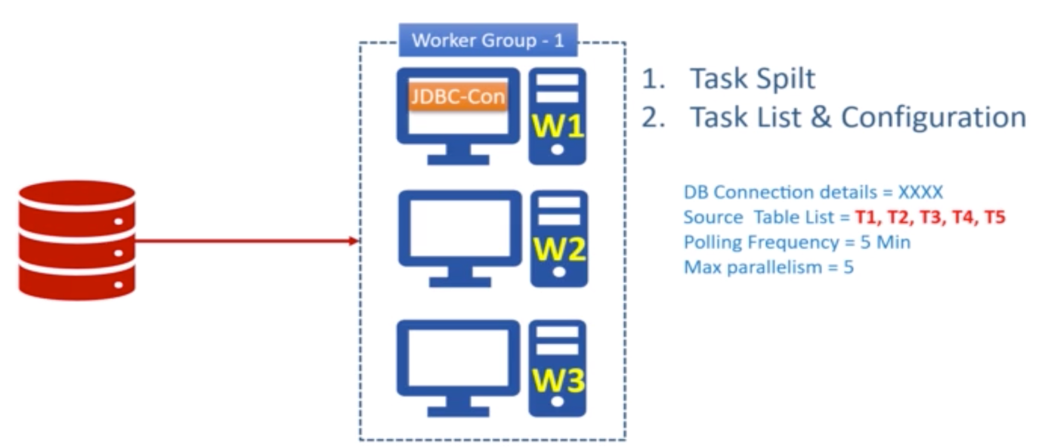

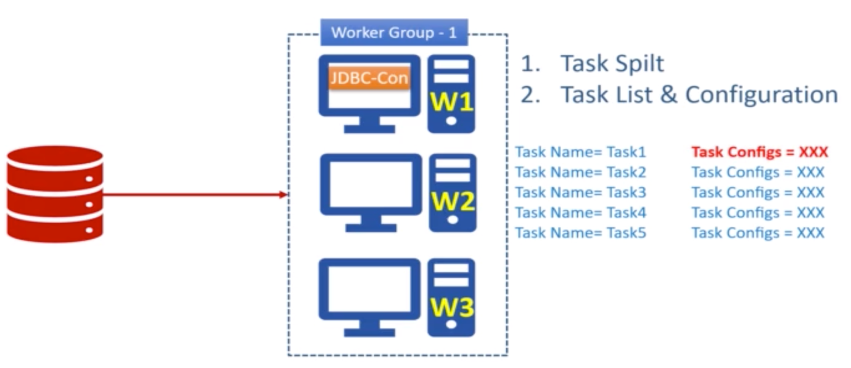

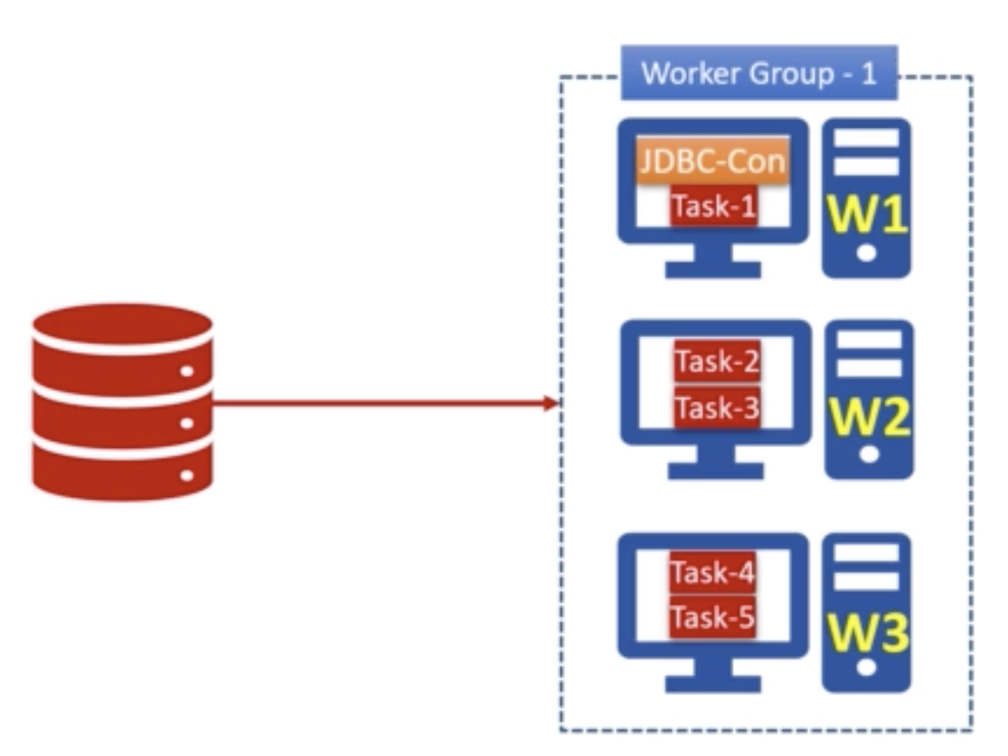

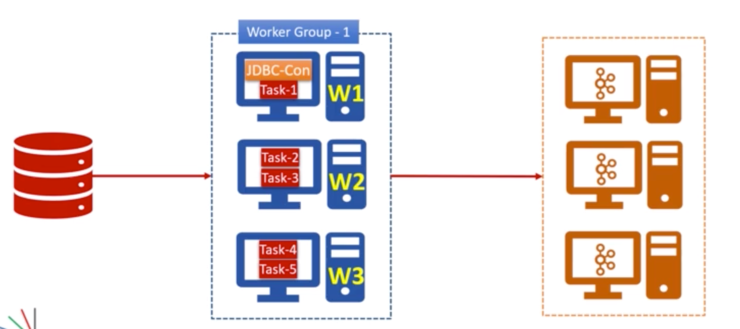

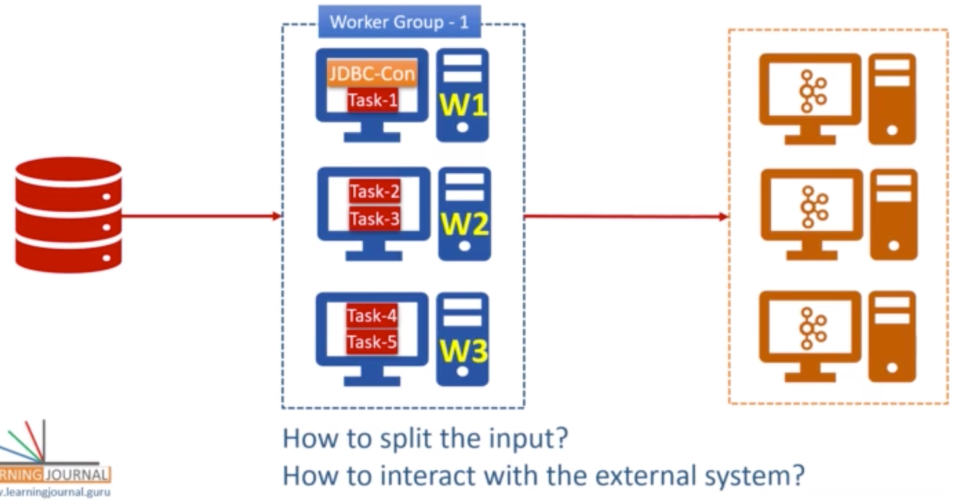

* **Kafka Streams Core Concepts:**

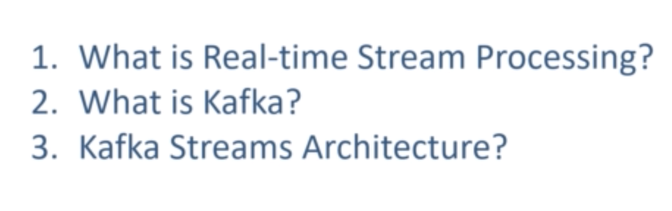

1. **What is Stream Processing?**

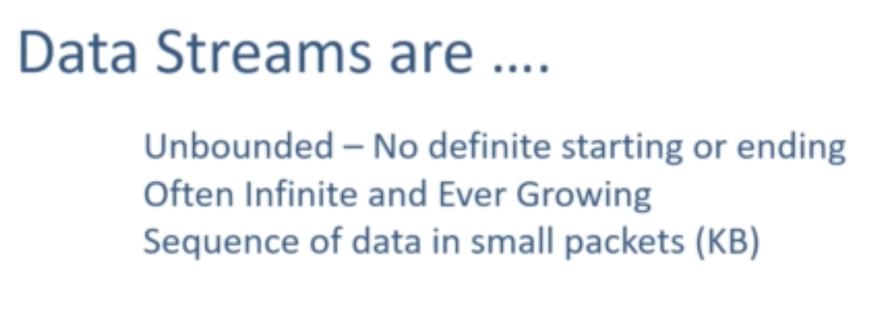

Unbounded - Infinite

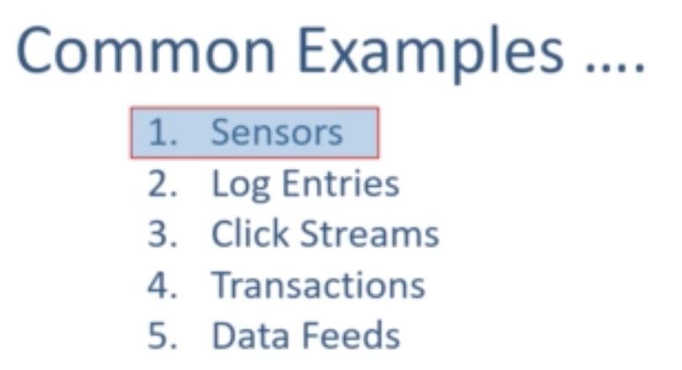

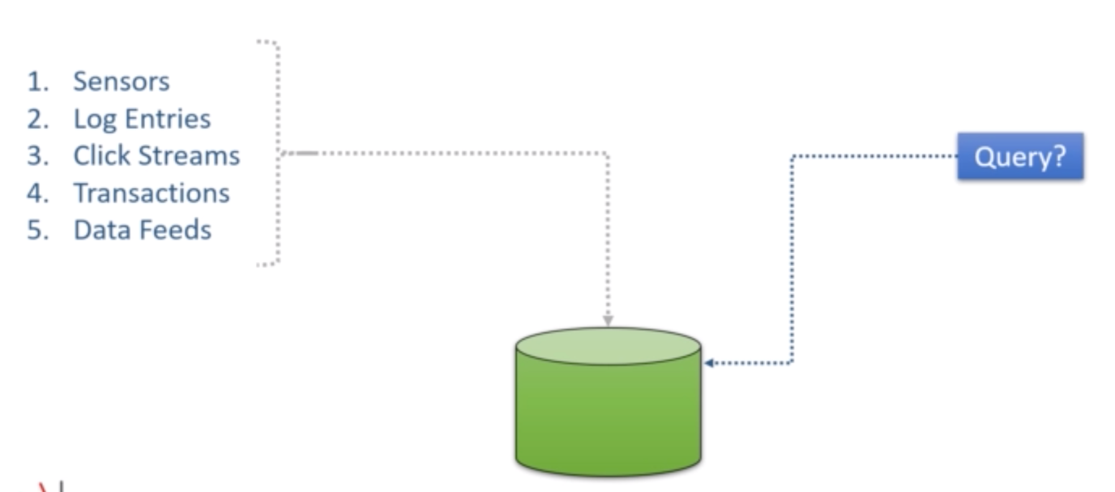

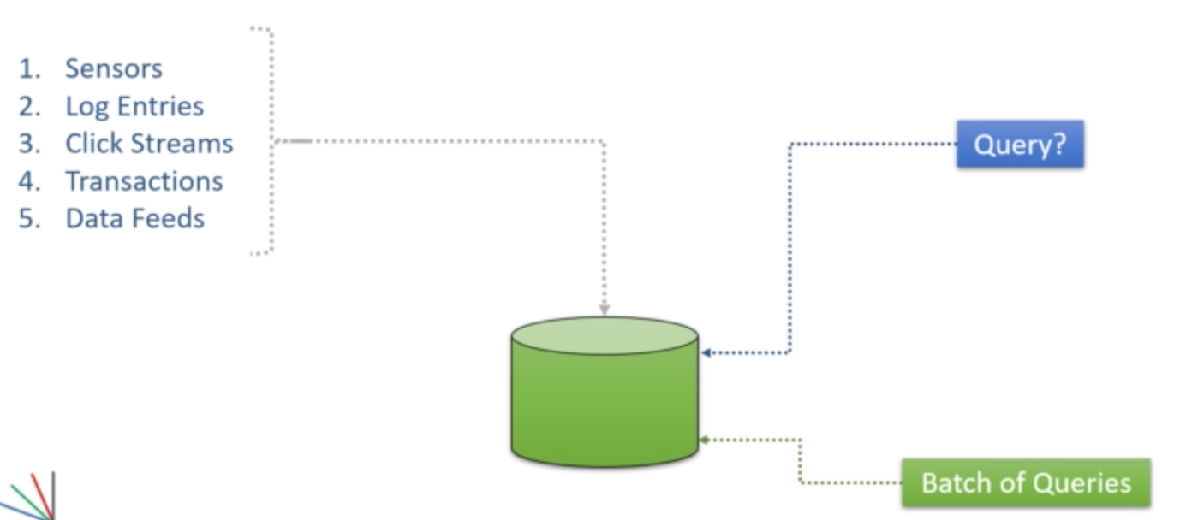

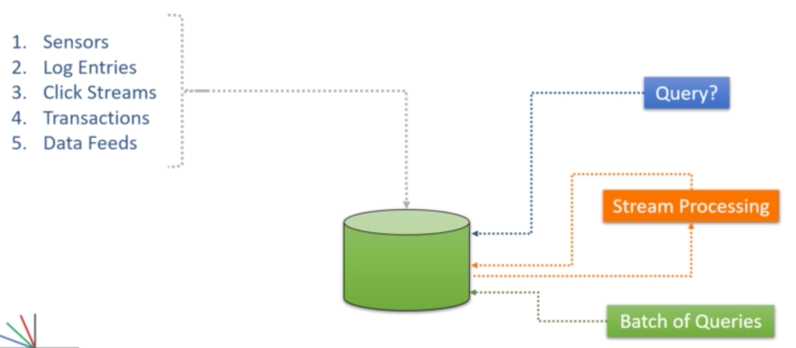

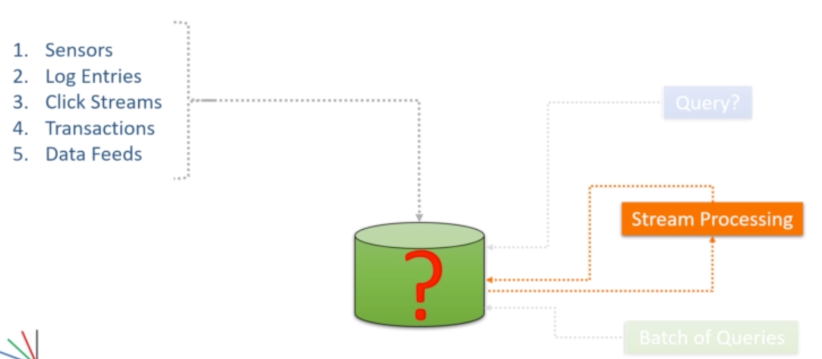

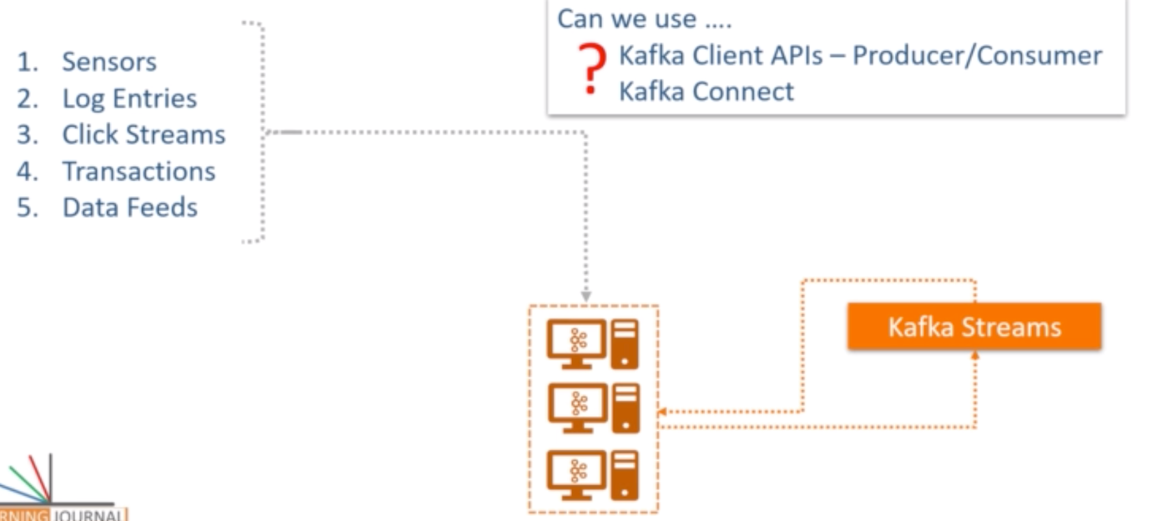

1. **What is Kafka Streams?**

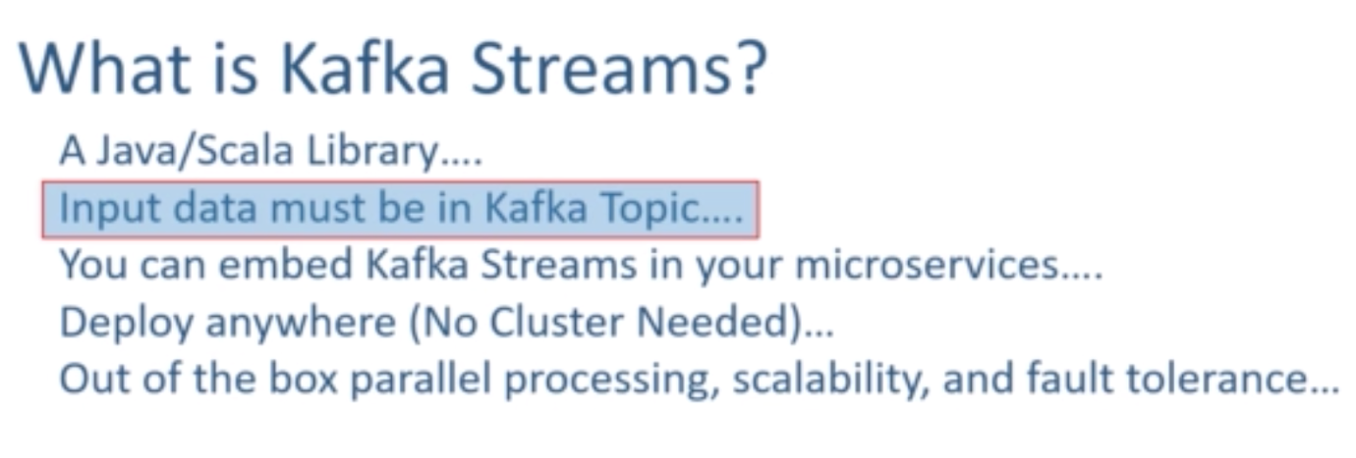

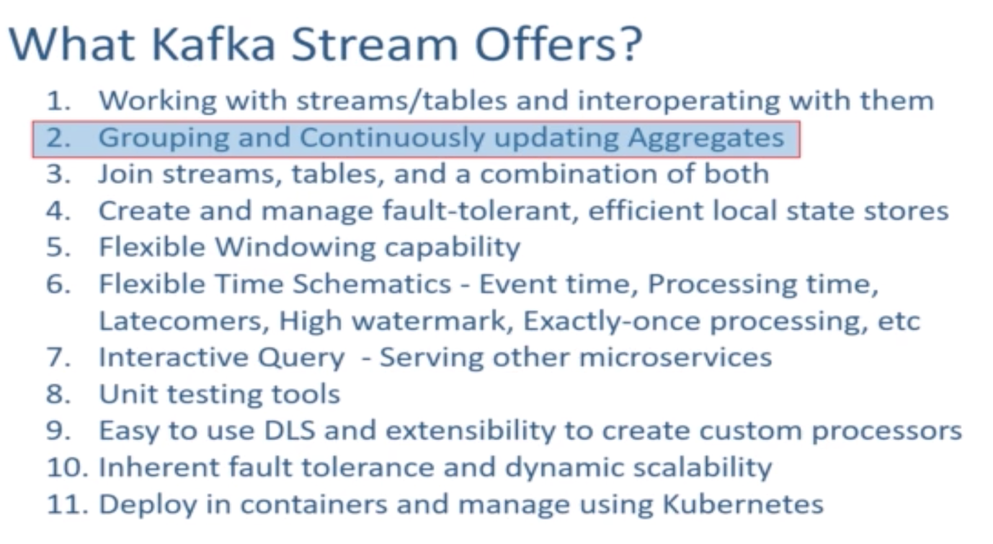

1. **Kafka Streams Architecture:**

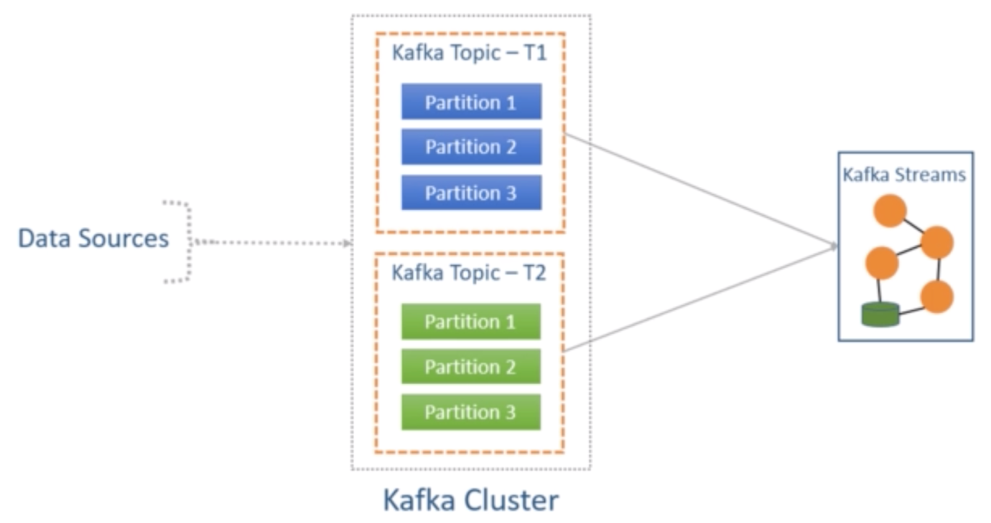

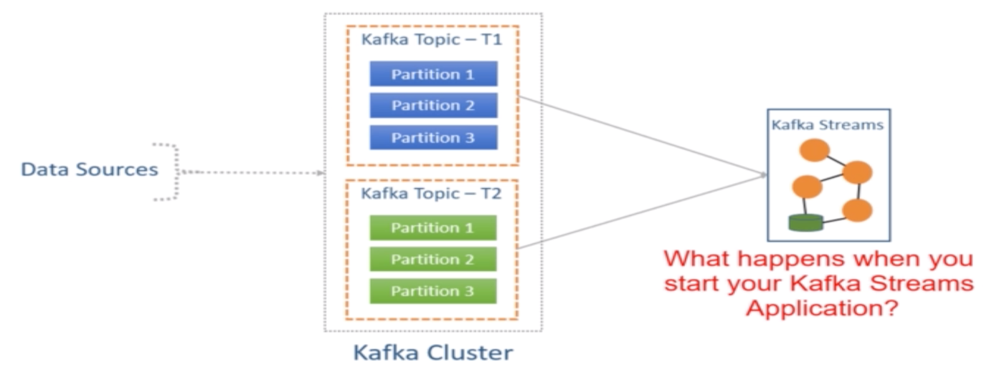

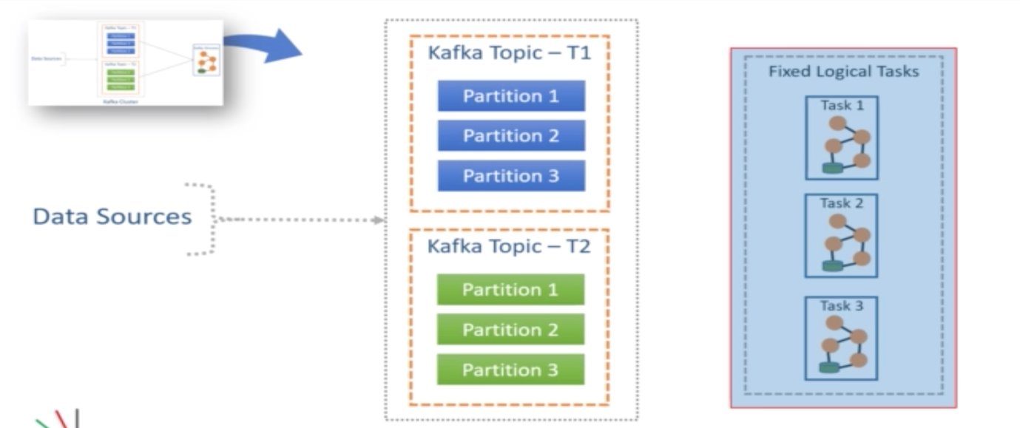

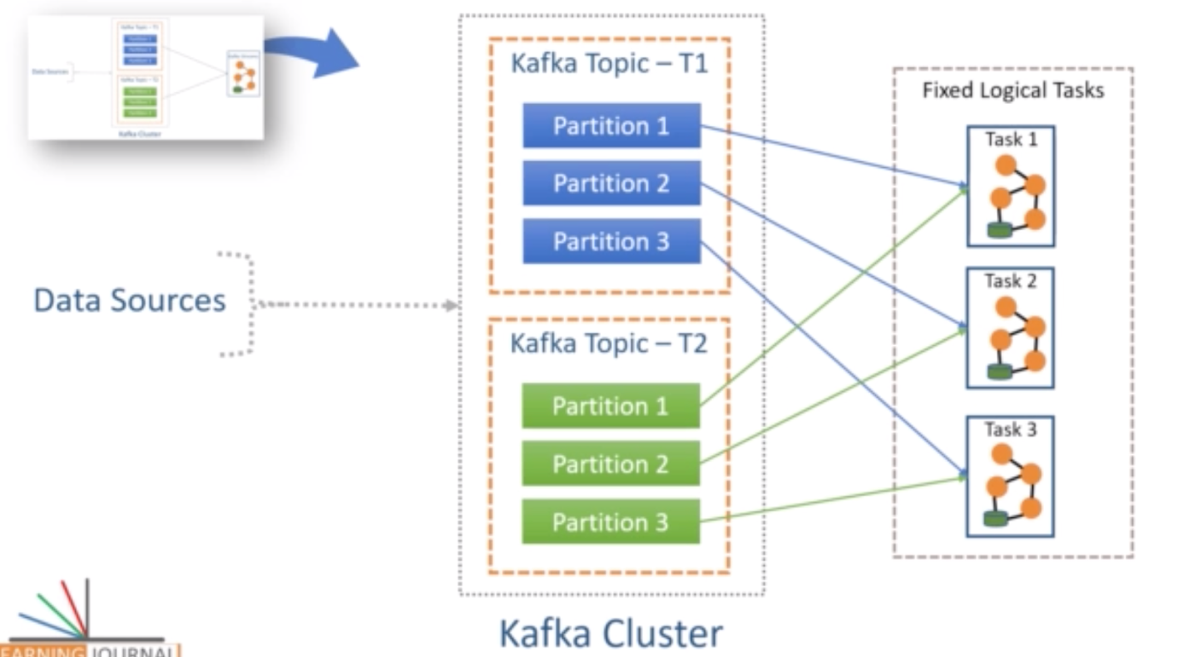

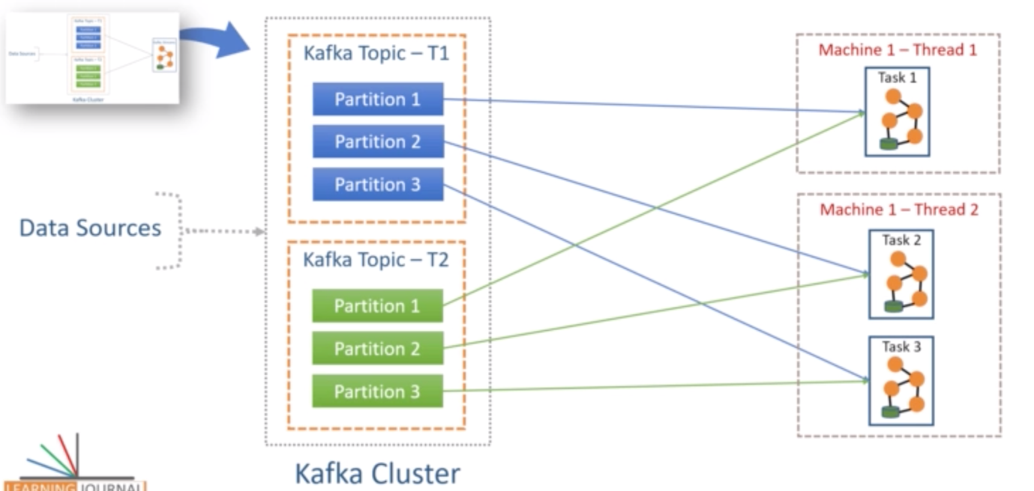

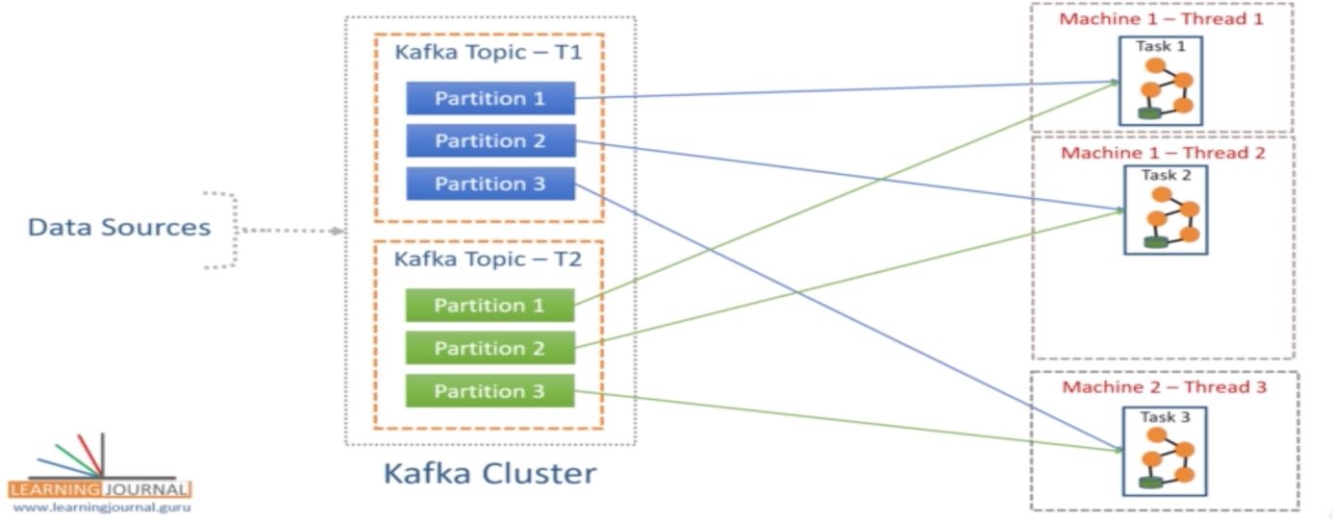

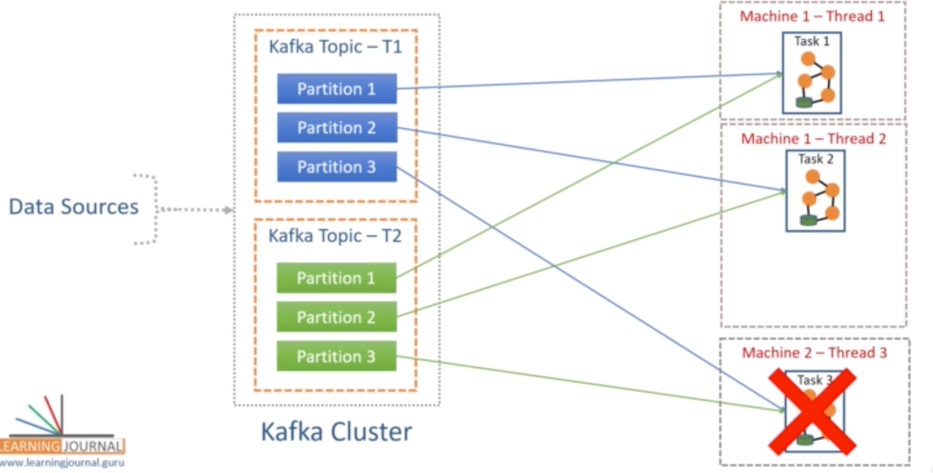

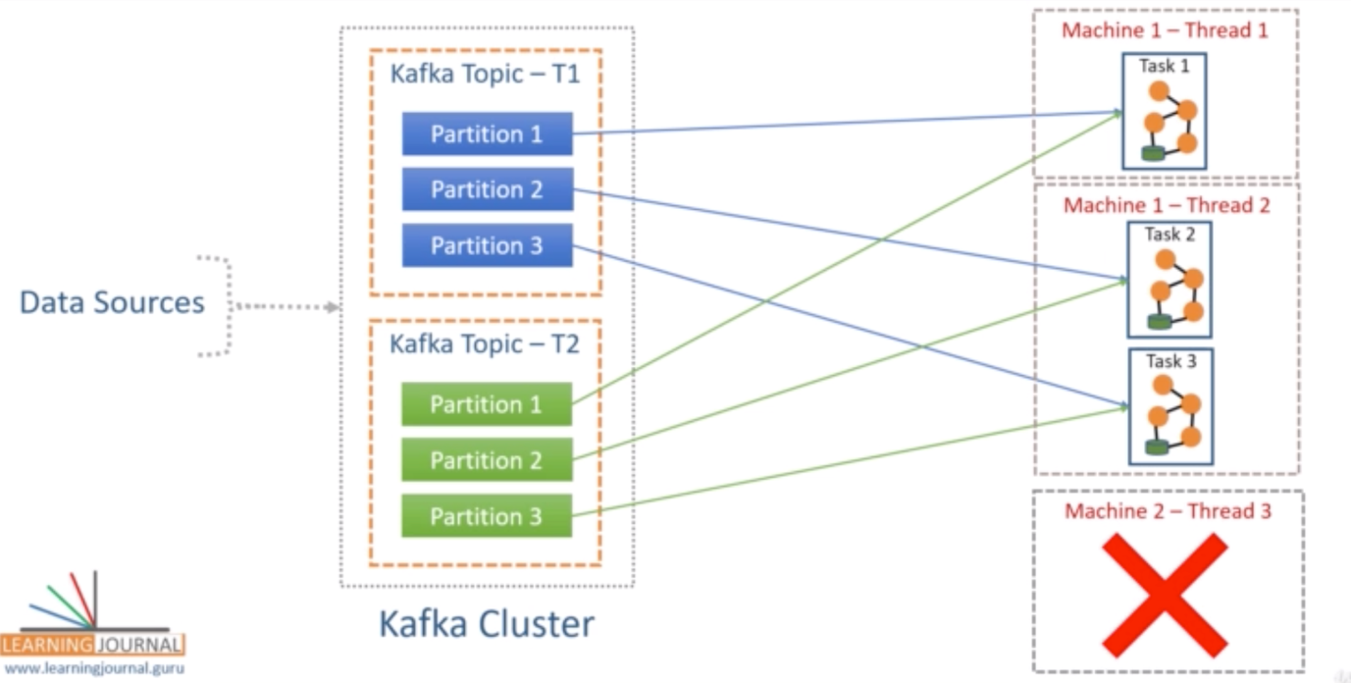

* **Kafka SQL Core Concepts:**

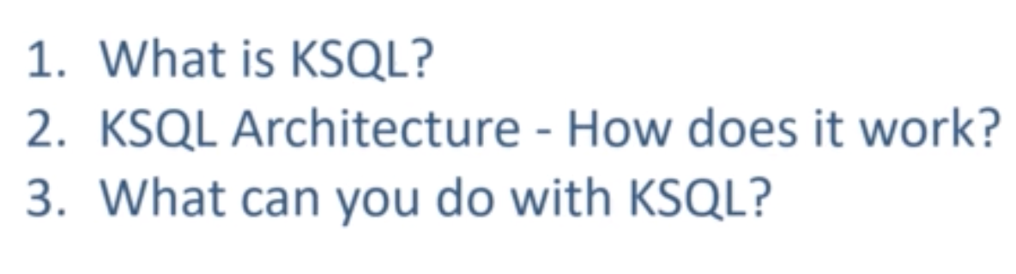

1. **What is KSQL?**

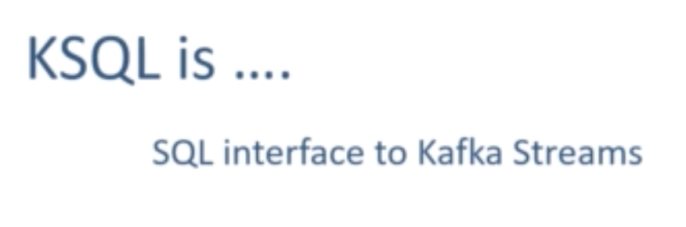

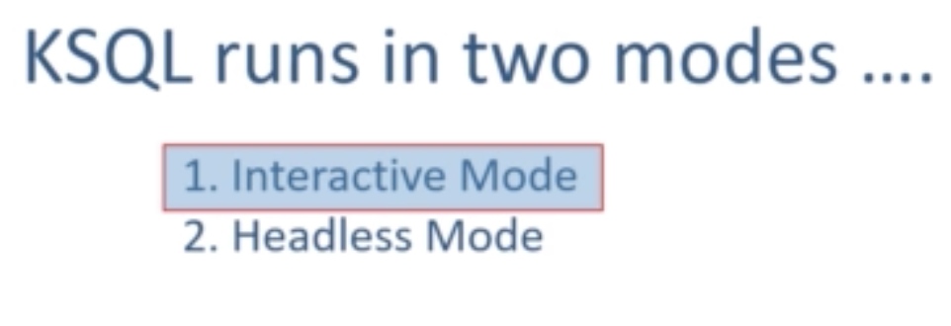

1. **KSQL Architecture:**

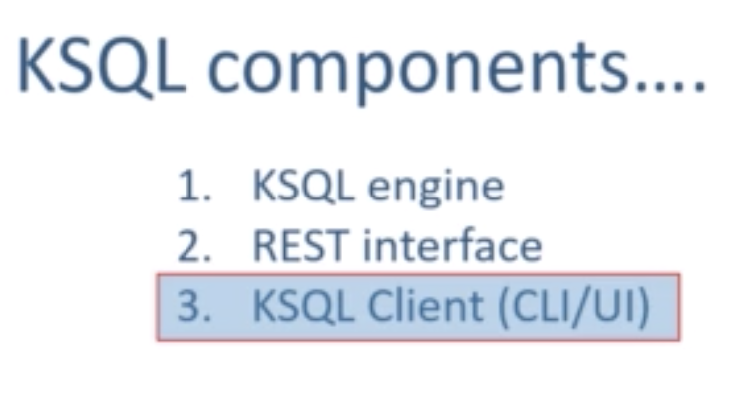

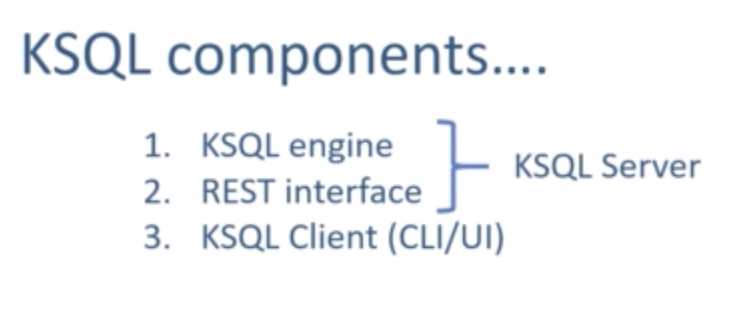

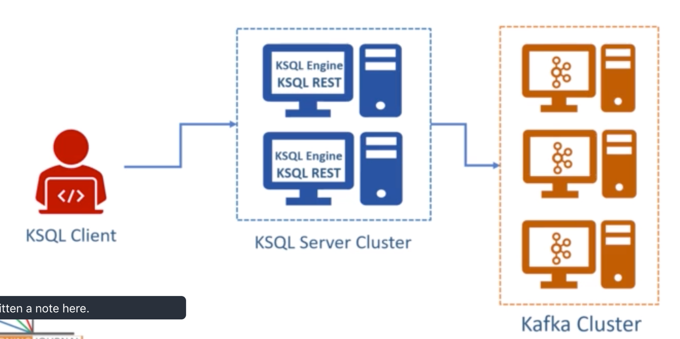

1. **What can you do with KSQL?**

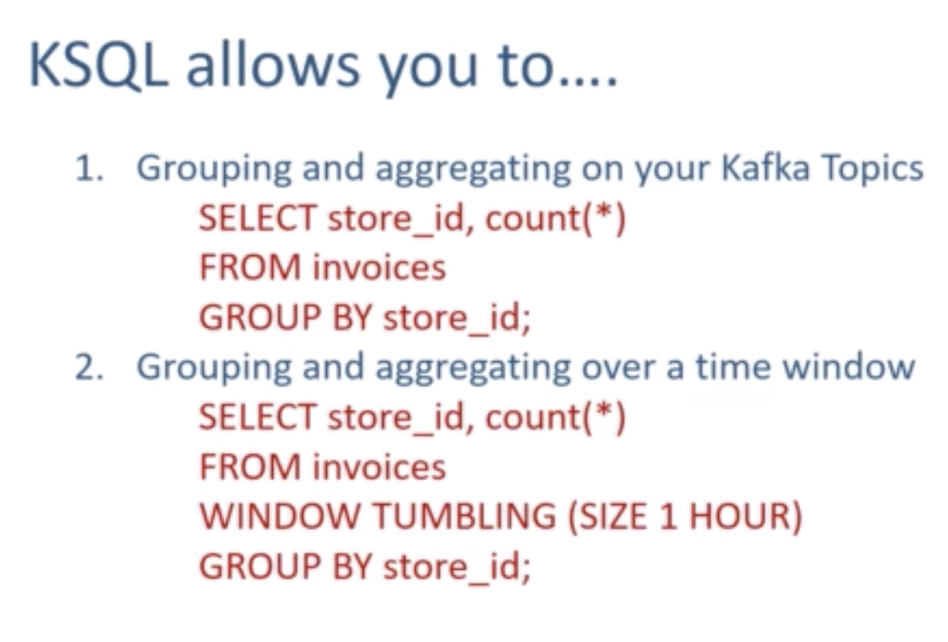

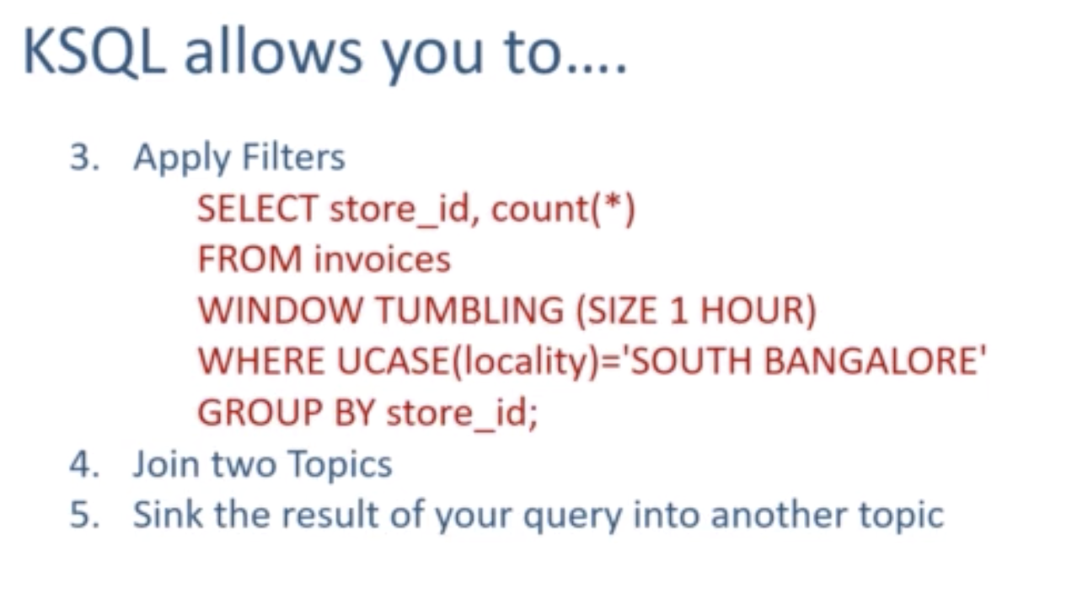

* **When to use What?**

